MARKETING PLAN
KENTUCKY'S FRIED CHICKEN (KFC)

Table of Contents
1. Company background 3
2. Situational analysis 3
2.2 External analysis 4
3. Marketing objectives 6
4. Business strategy 6
5. STP 8
6. Tactics and action 9
7. Budget 10
8. Control measures 10
9. Operation Plan 11
References 13

1. Company background
Kentucky’s Fired Chicken popularly known as KFC is an American multinational fast-food restaurant that is renowned for its fried chicken. The organisation was established in 1952 and presently has more than 40,000 outlets all around the world in about 130 countries. KFC occupies the second largest position in the world regarding the largest fast-food restaurant chain after McDonald's. KFC is the subsidiary of the Yum Brand, and the organisation follows the franchise business model that has led to the widespread expansion of the business. The organisation serves 12 million customers every day globally. The revenue of the business reached $13 billion in the year 2012 (Kfc.com, 2018).
The last few years have been quite tough for the business due to the increased consciousness of healthy food and the brand’s increased distance from its core values (Dan, 2018). The lack of practical business and the corporate strategy resulted in the decline of the sales. The present report provides an overview of the marketing plan based on a new strategy that would help KFC to grow and develop.

2. Situational analysis
2.1 Internal analysis
The internal analysis of the organisation can be done by assessing its strength and the weakness as is evident in the table below:
Strength  1. KFC has a strong presence with more than 40,000 location in about 130 countries. It is one of the market leaders in the fast food industry.  2. The brand has also increased its product line and is offering both the veg and the non-veg food items to its customers.  3. The secret recipe of KFC includes '11 Herbs and Spices' has helped the business to grow and develop. It is one of the famous trade secrets.  4. The franchise business model of KFC has led to the growth and the development of the business. | Weakness  1. KFC has negative publicity for offering unhealthy food as the items are fried, and hence they have high fat and calorie content. This has declined the sale of the brand.  2. The management of franchisee has become quite challenging. Maintaining the quality of the food is essential, and if one outlet fails to do so, it can lead to the negative publicity of the entire brand.  3. The bad suppliers often betray the trust of the brand. The supply of hormone injected chicken hampered the brand name.
Table 1: Internal Analysis
(Source: Kfc.com, 2018)

2.2 External analysis
The external analysis can be done through the evaluation of the external opportunities of the threats and weakness.
Opportunities  1. KFC has already a presence in 140 countries, and there are still chances of expansion in future globally.  2. KFC has the scope to introduce healthier options to the customers for attracting and regaining their trust.  3. Reinforcing its network outlet can help the brand to penetrate that will make KFC one of the leading fast food chains. | Threats  1. Increasing competition in the market is one of the significant threat to the business.  2. Changes in the eating habit of the customers have led to the decline in the sale of KFC.
Table 2: External Analysis
(Source: (Source: Kfc.com, 2018)
The PEST analysis would also help to identify the external factors affecting the organisation:
Political | The stable government of USA has supported the growth of the business. USA is a member of UN, and hence the business development expansion process has been more comfortable in the member countries. With the formation of Brexit, the taxation policies have seen changes in the UK (Heritage.org, 2018). The government of the countries frame pricing policies which KFC needs to maintain considering the income distribution of the people.
Economic | The economic freedom of USA is 75.7 which makes it as the 18th freest economy. The economic freedom of the country is low because of the development in other countries. The tax burden is 65.1 which is a decisive factor for KFC. The diversified economy has led to the development of the business of KFC (Heritage.org, 2018).
Social | The changes in the demography of the population of USA has changed the eating habit. People have become more health conscious. KFC needs to change their food items based on their food item. The increasing ageing population can create issues in obtaining the right human resource for the organisation.
Technological | The development of technology and research has changed the business perspective. KFC has invested in the technological development strategies for training and improving the efficiencies of their employees. Technology has also helped to improve customer service. Voice-activated training, Amazon Echo show and the online food ordering are some of the technological development of the organisation, (Restaurant Business, 2018).
Table 3: PEST Analysis of KFC

3. Marketing objectives
The marketing plan is based on the following objectives:
- To create awareness among the customers and create goodwill in the market
- To increase the sales of the organisation by 10%
- To increase the outlets by 5%
- To increase the profitability by 10%

4. Business strategy
Teece (2010) commented that business strategy is the means through which it attains the desired objectives. Business strategy can also be termed as long-term business planning. In this case, the business strategy for KFC would be assessed based on the Ansoff Matrix. This is a tool that provides a framework for strategic planning and enables the marketers and the management of business organisations to formulate strategies for the future growth of the organisation (Hussain et al. 2013).
In KFC, the process of strategic planning and the operational control is critical. KFC has always focused on the penetration and diversification strategy. Considering the present situation, the new business strategy of KFC has been illustrated in the figure below:
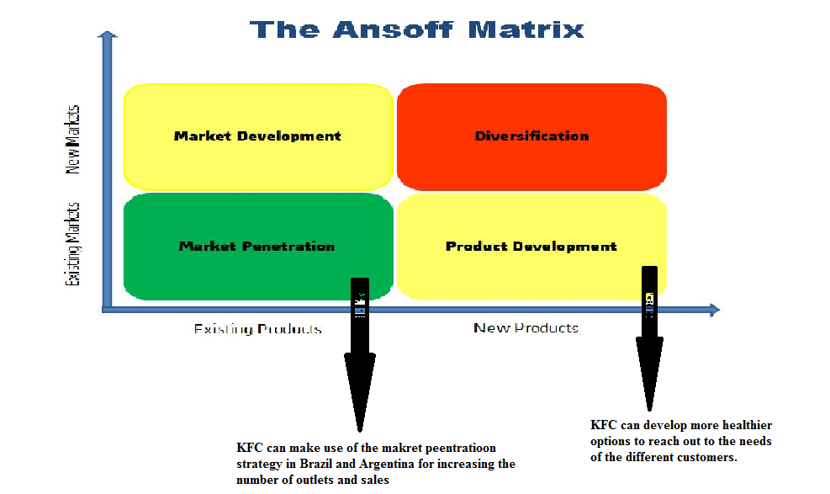
Figure 1: Ansoff Matrix of KFC
(Source: Kfc.com, 2018)
Market Penetration: Market penetration deals with the selling of the product or the service in the particular market (Hussain et al. 2013). KFC has focused on improving their presence in Brazil and Argentina. Hence, the market penetration strategy can help in doing the same by placing the existing products before the new target market. KFC can penetrate in the market of Brazil and Argentina by increasing the number of outlets. The new outlets of KFC through franchisee would help to reach out to new customers by selling more existing products and thereby gain the market share. It would help to secure over the dominant market and create a strong position in the market.
Product Development: The changes in the demography and the lifestyle of the people has brought changes in the buying process. KFC should focus on extending the healthier options by including more veg items and calorie-free items to the customers. This would help to increase the target market which in turn would increase the sales of the business. People have more conscious about their health, and hence they preferring calorie-free and fat-free food. Hence. KFC should develop this product line, and this can increase their reach towards the customers. It is recommended to KFC to create ‘Try Healthy, Be Healthy’ campaign in which new healthy products would be launched.

5. STP
The marketing plan would be developed based on the two new business strategy of market penetration and product development. Hence, segmentation and identification of the target and the forming effective positioning strategy are essential.
Segmentation | Demographic segmentation: KFC can target people within the age group of 6-75. The new healthier options of KFC has helped to extend the boundaries of the age groups. Both the male and females are targeted. The median income and higher income group are the primary targets of the business. The higher disposable income group are targeted for the premium food range of the business.
 | Geographic segmentation: The residents of the small and the big cities are the primary target of KFC. The market penetration strategy of KFC has also included the people of the rural areas as the new customer segment of KFC.
 | Psychographic segmentation: The middle and upper class of the society are the central segment of KFC. The gregarious, ambitious and luxury and brand lovers also form the customer segment of KFC. The people who are conscious of their health are the new customer segment of KFC.
Targeting | KFC can focus on localising strategy as its targeting approach. This helps the brand to better address the needs and the wants of the customers. The new target market of KFC includes the customers form 6-75 years, brand and luxury lovers and the health conscious people.
Positioning | KFC is positioned as the best chicken snacks brand, value for money and quality brand.  Recently, KFC is positioned as the healthier brand for the health conscious people with the tagline ‘Try Healthy, Be Healthy’.

6. Tactics and action
() Commented that marketing tactics are crucial actions undertaken for the promotion of the new products and the brands in the market and fulfil the marketing objectives. KFC for its penetration and product development strategy can make use of the following marketing tactics and actions:
- Social media advertisement: KFC can advertise about the new product lunch in the social media sites. Facebook, Twitter, YouTube, Instagram and Snapchat has increased the accessibility of the business towards the customers. The new advertisements about the new outlets in Brazil and Argentina and the new healthy food items would increase the awareness of the customers.
- Pay per Click (PPC): PPC would help KFC to bring customers from different sites to their page that would encourage to try out their new products. The new healthier product line that would be launched can be advertised on different websites along with a link, a click on which can bring the customers to the main page of KFC.
- Sponsorship: KFC can work on their corporate social responsibility through sponsoring events. For instance, the positioning strategy and the product development of strategy revolve around ‘Try Healthy, Be Healthy’. Hence, sponsoring campaigns and events on health and wellbeing and obesity prevention will not only increase the goodwill but would increase the trust of the customers and increase sales.
- Referral: KFC can develop the customer portal to influence the customers and the fans to share the positive sentiments about the new products or the outlets of the business. This would help to strengthen the relationship between the customers and the business. Social media message and blog post can help to carry out this type of marketing tactics by KFC.

7. Budget
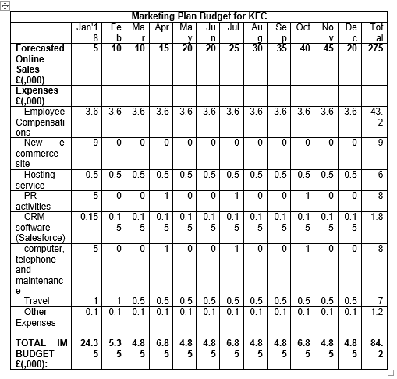

8. Control measures
The management of KFC needs to develop control measures to ensure that the marketing plan is successful. The control measure that can be used in this case is illustrated below:
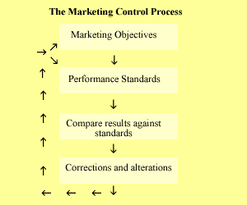
Figure 2: Control Measures for the KFC Marketing Plan
(Source: Perreault, Cannon & McCarthy, 2011)
The variables that can be used for the performance standards are:
- Sales figure
- Market share
- Profitability
- Consumer feedback
The result of the marketing plan can be obtained through survey and feedback. In case, the results are positive then the marketing plan would be successful and if contrary then corrections and alternations would be made (Perreault, Cannon & McCarthy, 2011).

9. Operation Plan
The operation plan for the marketing would include certain factors which are discussed in this section:
- Customer Relationship Management (CRM) is essential to establish a connection with the customers (Heller Baird & Parasnis, 2011). Innovation and technologies are essential to establish the CRM and make KFC more customer-centric. CRM would help to better place the brand and strengthen the relationship with the current and future customers.
- Website optimisation is essential for KFC as it is a marketing tactic and it would help to develop the connection with the public. The website of KFC would be more visible to the public as it would appear higher in the search engine. This would help to increase the popularity of the brand.
- The perception of the customers about the new launches and the new outlets would be acquired through a survey. The customers would be surveyed online in social media or through websites to know about their preferences for the products.
- A unique marketing team would be developed for establishing the concepts and carry out the marketing tactics and also collect data at the end of the marketing.

