International Intermodals
Introduction:
The term intermodal industry refers to the transportation of goods using multiple ways. The multiple ways can include rail, ship, trucks etc. Usually, the goods are transported in bulk by this industry and there is a specific term for this bulk goods. It is called freight. Therefore, the freight transportation means using the intermodal container like rail, ship or truck for the overall business journey. These intermodal containers are of high business demand because they increase the security of the cargo while reducing the damage and loss frequencies (Christopher, 2016). Moreover, the systematic service uses multiple strategically located facilities to maximize the transport efficiency in terms of logistics and delivery. In this report, an intermodal company is selected to analyze the important feature of an intermodal. The Company is called the ACFS Port Logistics. The high-end facilities of the company cover Sydney and Melbourne areas as well as other important transport points with its diverse client base. Moreover, the major services of the company include transport, logistics as well as pickup and delivery. The multi-location services are capable of dealing with all type, size and configuration of freights with 3PL, CPS systems and the cross docking services are added advantage too. However, the Australian national road network and rail intermodal hubs seem beneficial for the services while the company has priority access to the key ports. In this report, the major discussion points are the main problems with a current logistic network in Australia, government involvement in the logistics environment as well as recommendations to solve the issues.

Background:
According to the current scenario of the intermodal industry in Australia, the Department of Infrastructure and the Regional Development (DIRD) and the Australian Logistic council are highly significant for the future of intermodal terminals in Australia. The term logistics is defined as the end-to-end supply chain activities in the country and the logistics management is considered as the subset of the SCM (Schönsleben, 2016). The economic view of the country states that the industry contributes 8.6% of the GDP which is equivalent to the $130 billion revenue generation. Moreover, the logistics industry generates 1.2 million jobs currently and the latest BITRE estimation confirms that the domestic freight covers 600 billion tonne Kilometers in the internal demography. The industry has a huge impact on the country as merely 1% increase in the total logistic factor productivity can increase the GDP by $2 billion. However, the country faces several issues which can negatively affect the intermodal industry. As an example, the system of national account (SNA) still has limited information about the logistics industry which means the size of the industry is not well presented by the SNA.
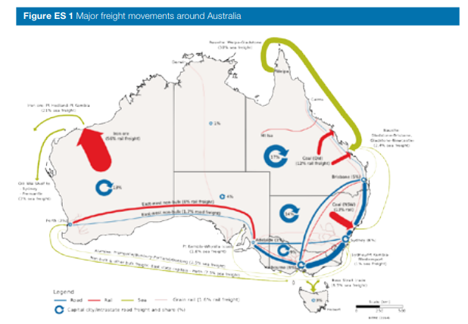
(Source: auslogistics)
Moreover, the current business trend suggests that the freight task is going to increase by 80% by 2030 while the growth rate will be triple by the year 2050. So, the volumetric growth may face transportation point difficulties as the transportation supply chain has limited growth. It is observed that every industry in Australia is dependent on the intermodal industry to some extent where the major factors are the low cost and speed of transport. Moreover, the same feature helps the exporters to reach new markets (Liu et al., 2015). In case of domestic manufacturing industry, the excellent transport and logistics facilities are important as they provide a cost-competitive image (for the manufacturing industry) in terms of cheap import and large area coverage. However, the major risks are discussed below.

Main problems with current logistics network:
In general, the BITRE has confirmed that the country is facing three major risks in the intermodal and logistics environment and they are:
- Urban congestion
- Limitation of the regulatory framework
- Increasing number of an aging workforce (Roso et al., 2015)
However, in terms of transport and service, there are more complex issues which are discussed below.
Rail-based SCM issues:
In the case of the rail-based supply chain, the intermodal terminals are facing some difficulties. The railway terminals are considered as the key connecting interface between rail network and customer-centric operations. So, the capacity and operations are the major success factors of the rail-based SCM. Now, the terminal throughput depends on the scalability and viability of the network where the fixed costs issues are increasing rapidly. In terms of operational development, the fixed costs include capital and operating expenses where the volume maximization has increased the terminal configuration gaps (Goetz et al.,2016). Again, the price competitiveness depends on the alternative supply chain options. That means the cargo owners are facing time and cost-effectiveness issues in the rail-based SCM.
Fragmented rail based SCM:
Another critical issue is the large number of fragmented components which affect the integrated logistics network as the single participant cost is distributed to other participants. Therefore, the total supply cost is increasing with the poor level of the optimization. The individual efficiency and capacity of the components are asymmetric which directly affect the behavior of the service providers in terms of control, responsiveness, and integrity. So, the supply chain coordination is the internal issue here.

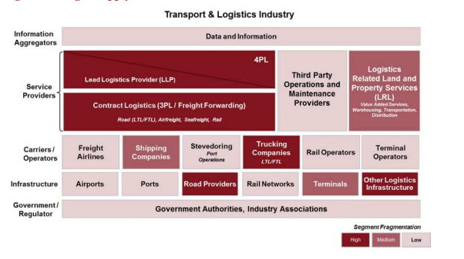
(Source: PWC)
Terminal capacity gaps:
The regional gap assessment confirms that Brisbane faces the premium train path issues due to commercial and contractual rigidity while the region lacks modern IMEX facilities. Again the port of Sydney has terminal bottleneck issues while Melbourne faces regulatory issues (Lease, relocation). Moreover, Perth has capacity gaps in terminal serving which is a key interstate infrastructure issue while the IMEX target has a fluctuating pattern.
Terminal scalability issues:
The rail and truck sites face turnaround time issues with loading extension, terminal configuration as well as lift equipment. Due to bulk export, the rail freight has increased but the maintenance cost is not properly distributed. Moreover, the winter capital and regional road corridors are increasing the infrastructure costs rapidly (Ji & Luo, 2017). There are lots of logistics regulation present in the domestic environment which increase the political pressure on the intermodal industry. As an example, the 2014-2018 strategic plan in the Northern Territory Department of Transport has potentially increased the reform complexity in the mentioned territory.
Regulation issues:
The regulatory environment is somehow based on the Bureaucracy which affects the cost and innovative solutions. Moreover, there are duplicate and inconsistent regulations which negatively impact the logistics network. As an example, the Road Safety Remuneration Act can suppress other laws including the Heavy Vehicle National Law which means the laws can overlap major incidents increasing the overall cost impacts. Again, the National Rail Safety Regulatory offices are established in different time periods increasing the service operators' difficulties. As an example, the office in Victoria was opened in 2014 while the offices in NSW, Tasmania were fully functional than (Vuchic, 2017). Apart from this, WA and South Australia are still not habituated with all versions of the rail safety regulations confirming the gaps. Finally, the design and safety standards in case of import facilities (mover, locomotive) face quality issues and difficulties to pass American and European tests which means proper regulatory actions are required.
Infrastructure investment issues:
The cost of congestion is increasing and currently, it is more than $20 billion per year. Again, the private capitals are not symmetric in the intermodal industry and it is reflected in the public infrastructure finance model. The government finance has not reached the optimal level where major regions are facing the sovereign debts and tax issues. The public-private partnership model has rigidity and the key infrastructure projects face poor value for money and high waste management issues.
Road, sea and air network issues:
The road freight model has flexibility issues as 95% road freight still use the heavy vehicles like B-double where the restricted road network is the highest suffering point. Apart from the congestion, the other issues are staff shortage and fuel costs. Moreover, the heavy vehicles increase road damage issues. In case of air freight, the country still has not used the opportunity completely which means it covers only time-critical and high-valued goods. The air freight model covers only 0.1% of the total domestic freight task indicating the freight pressure on the road and rail networks. Again, the sea freight covers the bulk minerals and other expensive natural resources which confirms the new port demand in the country. The bulk export ports are limited (SA, Victoria). Therefore the country needs a total reformed intermodal planning. However, the urban planning is not in phase with the intermodal networks therefore, the country faces warehousing issues in the peak traffic.

Resolution strategies:
Considering the terminal, operator and cost factors the company (ACFS) can use the following strategies:
Introducing intermodal typology model:
The company can use three major types of terminals and they are regional, metro and port terminals. Moreover, the regional terminals can be based on interstate rail and inland rail. In the case of the metro, there are small IMEX and major interstate classifications. The typology model can help to identify the major challenges and in terms of terminals, inform planning and investment decisions etc. Moreover, the model can help to build the reference framework covering the intermodal terminals. The reference framework can use the transport needs, network assets to deal with the key challenges in the environment. In regional terminals, the PUD legs, definitive radius, 3PL and LCL can help while the increasing service frequency in IMEX terminals can increase 2 times return per week. The operating model can use both privately owned line haul operator as well as specific catchment areas for the services. In metro terminals, the seasonality, reference trains and terminal envelope can help to reduce the rigidity issues while the short-haul port terminals can introduce more forklifts, reach stackers as well as short-term container storage to deal with congestion and cost issues.
A reformed SCM plan:
According to the intermodal limitations, the country (Australia) needs multimodal networks with flexible port strategy. The planning is majorly focused on the individual modes which mean covering the overall freight movements the company needs a well-situated and wide community-based planning. The warehouse management system should be world class which means the operational model should cover the following features:
- Intuitive inventory control
- Remote stock management with advanced technology
- Customer link facilities
- Increasing the strength of 3PL logistic divisions
- High transporting facilities in terms of maximized productivity and minimized cost ( high number of pallets/ load, high weight, and goods capacity management)
- Large numbers of warehouse extensions
Robust warehousing and postal services:
The country value-added services confirm that 45,000 people are currently employed in the warehouse and postal framework and the same population produces 2.2% of the quality services. Therefore, the company should strengthen its warehouse and postal framework to widen the community services. However, the postal services face redundancy issues frequently but the company can try high-end technologies to solve the problem. Considering the stock holding cost and overall logistic cost should create a planned warehouse framework on the existing terminals The popular existing terminals are Moorebank, Enfield in NSW, Altona, Dynon in Victoria etc.
Macroeconomic factors:
As the manufacturing, forestry, construction, wholesale and retail industries are directly dependent on this industry, therefore, integrating the intensive user communities can be helpful. Considering the global labor market and fixed labor supply the company can introduce new terms of domestic and foreign trades using the existing investor networks.
Integrated urban planning:
This is an indirect resolution strategy. The company can take the advantage of new domestic urban planning feature in Australia. Considering the high economic impact of the logistics industry the business model of the country is using new freight plans. In this context, the National Land Freight Strategy is significant because the strategy covers all modes of transports with a long-term focus (Agamez-Arias & Moyano-Fuentes, 2017). Therefore voicing for the urban planning can help the company deal with its current issues. The corridor protection and efficient sub-optimal route building will be some of the major features. Moreover, the alternate routes like tunnels, water facilities are important too.
Highly productive vehicles and railway:
As the road capacity is often affected by the high fright volume, therefore, using more rail networks can decrease the congestion issues. Again, the aim of doubling the freight volume by 2030 can only be established using the rail and sea network. However, the short haul rails should overcome the PUD and cost issues which means using long-haul trains with a double stack and small port shuttle options can be helpful here. Moreover, balancing the passenger services and introducing an innovative charging regime for road vehicles are important.

Government involvement:
First of all, there are lots of freight and transport strategies used by the government. But the major issue is the terms of balance and consistency. Moreover, the regions face different versions of the strategies which may increase the confusion in the business environment. Therefore, the different degrees of help should be removed while introducing a balanced strategic version for all the Australian regions. As an example, the harmony in legislation can reduce the red tape issue with a complete SCM and urban planning. Moreover, the strategies like Moving Freight, NSW Freight and Ports Strategy, National Land and Freight Strategy must have some common themes to deal with the diverse logistic issues in the country. To reduce the potential gaps in the logistic capacity the government (territory, state) needs regular IRBC based demand forecasts, terminal gate capacity analysis, modified operational procedures, load siding extensions etc. In case of accessibility and contractual challenges the lease conditions, path availability, unfettered access as well as network constraints must be considered. Moreover, the government can introduce new investment roadmap (covering high investor satisfaction rate), transport planning, long-term operational policy framework etc. The network and transport assessment model should cover the followings:
- Time-based road and bridge strategy
- Management streamline and infrastructure development program (considering the voice of the intermodal industry)
- Private investment model to reduce the red tape issue
- Decreasing time limits of road access planning and approvals
- Flexible land tenure requirement policy (Kuzmicz & Pesch, 2018)
- Improving the territory roads with duplicate rod options
- Supporting the road upgrade model as well as urban streetscapes
Moreover, the modern regulatory regime must cover the followings considering technical components:
- Reviewing and improving the delivery services targeting 5-10% of the annual increase
- Increasing transaction proportions of the relevant external services
- Increasing wait times in the vehicle offices
- Encouraging development of remote transport infrastructure
- Reviewing the road, sea, and rail safety policy to improve passenger behavior
- Serving drive safe remote programs, penalty notification
- Increasing the air transport features
Finally, the workforce planning should use
- Recruiting new and expert staffs
- Promoting leadership
- Creating flexible workforce metrics
- Monitoring the aged and new workforce population ratio

Conclusion:
The report has discussed the domestic intermodal environment of Australia because the ACFS has multiple business locations covering the important terminals like Brisbane, Sydney Melbourne, Fremantle etc. Therefore, the rail dependent logistic framework of the country needs more alternative modes like water, air, and road. In this context, the government can help with robust path planning and investment management. Moreover, the regulatory framework faces consistency issues so the company should voice the value-added changes in the industry with direct government approvals.

