al Ain hospital

2017
IMPACTING OF EFFECTIVE SERVICE TO THE RESPONSE OF CUSTOMERS’COMPLAINTS

[Type the company address]

IMPACTING OF EFFECTIVE SERVICE TO THE RESPONSE OF CUSTOMERS’ COMPLAINTS

Abstract
The paradigm of the research is based on the feedback of the patients of Al Ain, hospital of UAE. It is important to understand the requirements of the customers in order to better the quality of the service of any organization. This study explores the moral needs of the patients in order to understand their satisfaction in respect of the services provided by this Hospital. The research is primarily based on the primary data which has been gathered from the feedback of the patients regarding the issues they generally encounter. An appropriate methodology has been used in order to formulate the research.

Acknowledgement
This project would not have been possible without the help of the lecturers and guides. They have provided me with immense support and encouragement, which worked as the driving force in the commencement of my research. I also want to thank my friends and peers for their help and support. Last but not the least I feel highly obliged, grateful to my parents, and family for their compassion and constant support.

Chapter 1: Introduction

1.1 Introduction
Satisfying the needs and the requirements of the customers and targeted beneficiaries is among the main aims of any financial organisation, regardless of the field, sector or industry that the said organisation belongs to. The satisfaction rate of the customers is one of the most important matters for consideration in this regard, as the high satisfaction rate of the targeted consumers are the main measuring stick by which the success of any firm or financial entity is determined. The organisations providing services in the healthcare sector, such as the hospitals and the clinics are not exceptions to this role. Indeed, their need for satisfying their customers (in their case, the patients) as well as all of their main demands and requirements are particularly higher than their peers in the other industries, owing to the fact that the very well-being of the patients is under their complete care. Any lapse or limitations in their service delivery aspect are amply reflected by the complaints and negative feedbacks that the patients and their family members provide, which in turn has to be considered as an opportunity for improvement rather than just a factor of discouragement (AL AIN, 2017).
The following study has provided details regarding the condition of Al-Ain hospital in Al-Ain, one of the largest cities of the United Arab Emirates. Main problems which have been observed in its functioning, as well as the attempts to provide a relevant solution for the same by using certain analytical and data gathering tools and methods, have been done (AL AIN, 2017). A thorough understanding of the main problem for consideration as well as the intricate details regarding the same has been attempted for completion, which has led to the use of certain tools and methodologies for attempting to deal with the same. Herein, this study is about the main problems of the Al-Ain hospital in Al-Ain, UAE with a specific focus on the main problem of customer complaints, as well as an intricate focus on the effects of proper responses to the said complaints on the mindset of the targeted beneficiaries (the patients and their relatives).

1.2 Problem Statement
The complaints from any kinds of customers are an indication of a limitation or inhibition in the achievement of providing effective and efficient services. In the case of the Al-Ain Hospital, the main observations have indicated that the staff members, while completing their allocated tasks, sometimes forget or refrain from providing additional help to the patients in question. There have been cases where a patient, just after a major operation, has been provided with food, but the caretakers and nurses in question did not try and help the patient in eating the food or in completing their daily tasks. Naturally, this became a source of complaint, as the patient became concerned regarding the lack of effort on the part of the caretakers and the nurses in particular (AL AIN, 2017). While these kinds of cases are few and far between, the fact that they have been observed is a serious matter for consideration. Thus, the main question, in this case, is regarding the methods which can be employed for reducing the said problematic behaviour from some of the staff members.

1.3 Definition of the Problem
The main way in which the problem can be defined is a question, which is given as follows:
- How can the behaviour of some of the staff members of the hospital be reduced and what kind of effects will they have on the complaints related to the same?
Upon answering the aforementioned question, details regarding the effective solutions of the given problem as well as the management of future situations of this nature can be defined and prevented.

1.4 Objectives of the Research Study
The main objectives of the research conducted in this study are:
- To answer the main question posed by the problematic situation, as well as ensuring the completion of the analysis of the main problem of staff-related behavior and the resulting complaints
- To ensure the development of a proper solution to the problem in question
- To determine the effects of effective service and proper solutions in response to the complaints of the customers and targeted beneficiaries

1.5 Target Audience
The main beneficiaries of the conducted research include the hospitals, especially the main hospital under consideration in this study (Al-Ain Hospital, Al-Ain, United Arab Emirates) as well as the patients, who are the intended beneficiaries of the services provided by the healthcare organisations and hospitals in question. Future occurrences and problems related to these issues can also be mitigated using the contents of this study, to an extent, as well.

1.6 Research Hypothesis and Relevant Research Questions
The main hypotheses which can be generated in the context of this research study are:
- H0: Providing effective services does not have an effect on the responses and the complaints of the intended customers.
- H1: Providing effective services has a deep effect on the responses and the complaints of the intended customers.
The main questions which are attempted to be dealt with in this research study are:
- How can the issue and problems such as the lax behaviour of some of the staff members of the hospital be mitigated and dealt with appropriately?
- What kind of effects will proper services in this regard have on the complaints related to the same?

1.7 Identification and Labelling of Variables
The identification and labelling of the main research variables are essential for the completion of this task. The main variables which are of use in this study include the independent variable, as well as its dependent counterpart. The quality and effectiveness of the provided services prove to be the independent variable in this study, with the responses and complaints of the customer being the variable dependent on the same. Using the analytical tools and techniques for determining the extent of the relationship between the same is beneficial for the effective completion of this study.

1.8 Limitations and Boundaries
While this study has been attempted in order to understand and provide an effective solution to a serious issue, the main limitation is the small sample size of the people who have been asked for providing help in this aspect. Only twenty participants could be gathered for the purpose of conducting a proper analysis pertaining to the main needs and requirements of the study in question. Furthermore, the scope and magnitude of this research are limited to the functions and boundaries of just one particular hospital, with the use of several hospitals and a greater magnitude/extent of the study being desirable in these kinds of research. Thus, the size of the available sample and the limited resources and participants prove to be the main limitations and boundaries of this research study.

1.9 Overall Arrangement and Approach of the Study
Gaining a proper level of understanding regarding the main issue under consideration in the study is crucial, with it being the first step for consideration while planning the effective and efficient completion of the same. The use of surveys and questionnaires to a group of participants (who can range from the head of entire departments and director to the other members of the hospital staff), with the analytical tools in question being extremely helpful in the determination of the magnitude of the problem as well as the development of an effective solution for the same. The process has to be completed in a step-by-step manner, in order to prevent any kind of confusion. Furthermore, the staff members and the participants have to be communicated with beforehand in order to set a proper date for the initiation of the research. Finally, the generated results have to be compiled, with the development of an analysed solution being the final solution needed for the successful completion of the conducted research.

Chapter 2: Project Proposal and Planning

2.1 Overall Research Methodology

2.1.1 Main Methods used in the Study
The main methods employed for initiating the study in question have been surveys and questionnaires, which have the advantages of gaining a relevant amount of fairly accurate data in a comparatively short period of time. Gaining the information directly from the people in close proximity to the healthcare organisation under review in this study is extremely beneficial, as the data gained from the sources in question have a high chance of being helpful in the development of a determining and comprehensive answer to the main question of consideration in this research study. The answers can also help in paving the way for the effective development of the solutions which can be helpful in mitigating the main issue which has plagued the hospital under review in this study ().

2.1.2 Used Research Methodology
The main model which has been used for analysis in this research is the model provided by Saunders and his colleagues. The model in question, the Research Onion, has the advantage of helping in understanding the research philosophy, the problem, the approaches to be used as well as the most effective way of analysing the main issue under consideration. The model in question has provided the main advantages of providing effective answers and analytical methods for completing the process of understanding and developing the necessary solution to the problem in question and the research question in general in a proper, effective and desirable manner (Cambra-Fierro, Melero, & Sese, 2015).

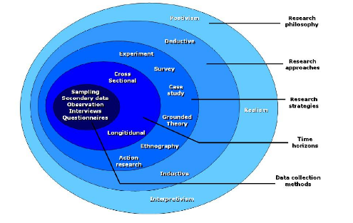

Figure 1: Research Onion
Source: (Cambra-Fierro, Melero, & Sese, 2015)

2.2 Corporate Description

2.2.1 Activities of the Organisation
The organisation under review in the research study is one of the largest healthcare service providers in the city of Al-Ain, with it being one of the most well-known hospitals in the region as well. Being a modern hospital, it has all of the necessary aspects and factors that a hospital needs in the present day scenario, with it containing most of the recent and modern technological tools and techniques for dealing with most of the problems pertaining to healthcare. Indeed, the presence of a highly trained staff of doctors and physicians has ensured that the hospital in question manages to provide very high-quality services, as far as the treatment aspect goes. The hospital also possesses the facilities of advanced surgeries in fields such as neuroscience as well. The organisation in question currently has the aim of improving on it already formidable and good quality treatment services (though the aspect of patient management by some of the caretakers needs improvement). Thus, the current activities include providing treatment to patients suffering from a range of ailments, injuries and problems, with surgery also being conducted in the organisation in an efficient manner as well (De Ruddere, Goubert, Stevens, & Deveugele, 2014).

2.2.2 Strategic Management Strategies of the Organisation
The main strategies which the organisation has used include the management of all of the aspects of its functioning in a planned and stepwise manner, which includes the management of the tools, techniques as well as the different members of the staff separately.
Aim of the Organization
The main aims of the hospital include the alignment of the working ethic of the different members of the staff with certain values such as innovation, sustainability, quality management, cultural sensitivity as well as transparency.
Vision of the Organization
The main vision which the hospital aims to work in accordance with includes the aspect of integrating the best possible quality of services related to healthcare with the highest standards set by the international measurements of safety and quality management(AL AIN, 2017).

2.2.3 Current Projects
The healthcare organisation has undertaken the initiative to arrange a conference on the field of radiology, with dignitaries and eminent scholars from all over the world being invited for the same. It also aims to engage in a project related to the development of a workshop of radiology, with the main intention being the attraction of several scholars and experts of the fields and requesting them to provide guidance to students and trainees aspiring to proceed further with their career in this field. The hospital also aims to initiate such the development of a timeline for the conduction of these kinds of conferences for the period of the next few years as well (AL AIN, 2017).

2.2.4 Industrial Analysis
Among the best ways of conducting a proper industry analysis is the use of Porter’s Five Forces Model. The forces in question include the bargaining power of the suppliers as well as that of the buyers, the level of rivalry in the industry, the threats of substitutes as well as the threats posed by new entrants. The current position of the hospital under consideration in the study is quite satisfactory, as the organisation maintains its status as one of the largest hospitals in its city of operation (Einwiller & Steilen, 2015).
The main suppliers of the tools and instruments of use for the staff members are in a position of influence, with the maintenance of a strong relationship being essential. The hospital has managed to achieve the same, with a certain amount of attention also being required for the bargaining power of the patients and their relatives. The complaints made by the patients are a matter of serious consideration, as a lack of satisfaction on their part is detrimental for the hospital.

Porter's Five Forces
Bargaining Power of Suppliers
Bargaining Power of Buyers
Industrial Rivalry
Threats of Substitutes
Threats of New Entrants

Figure 2: Porter’s Five Forces Model
Source: (Grainer, Noble, Bitner, & Broetzmann, 2014)
Rivals such as the Tawam Hospital can be a significant challenge for the Al-Ain Hospital in the coming years, with them gaining in reputation and almost rivalling the latter in operations as well. Newhospitals and healthcare service organisations have to expand considerably before posing a significant threat in the region, thus, the threat of new entrants in the current scenario is low. Finally, substitutes such as nursing homes can be a threat when it comes to the lesser services such as treatment of certain ailments, though their fairly lower number in Al-Ain has resulted in them not being very significant threats in the current scenario.

3.0 RESEARCH RESULT AND DATA ANALYSIS

3.1 Organizational Analysis
In this context, an old adage can be recalled that insists to emphasize on the customer loyalty, which inevitably retain the customer satisfaction without any additional effort. As per the previous apprehensions, the Al Ain hospital is supposed to be convicted because most of its staffs are quite aware about their job roles but their professionalism exhibits an irritating smugness, which refrains them to get involved in the additional activities regarding their regular tasks(AL AIN, 2017). Moreover, it is evident from their attributes that they are dedicated to retain their professionalism while do not even bothering about the moral liabilities that they are obliged to perform. They appear quite corporate regarding their demeanors but refuses to be humanitarian as it seems that they does not hold any responsibilities except the tasks that they are assigned for.
It has been also found that this subtle dimension of misconduct bears a hierarchic heritage since the consultants, experts and subordinates are prone to deny this as misconduct and appear adamant to justify that. Moreover, the absence of a considerable buzz further consolidates their stand in the premises though most of the potential patients have been seen to be vocal about the harsh attributes of the attendants(Yilmaz, Varnali, & Kasnakoglu, 2016). This is obviously not potent enough to shake the moral understanding of the subordinates of the respective health care unit, which further supplements to the consolidation of the objective of the proposal.
The feedback portal that has been provided in the official website and in the quarters of the unit appear flooded with the remarks of the patients that constantly complains about this subtle misconduct exhibited by the subordinates(Sparks, So, & Bradley, 2016). However, the organization appears rigid to take any considerable step regarding the demeanors that the subordinates are prone to dispense. This gross neglect of customer feedback can pose a potential impediment in the way of Al Ain hospital that might enable the respective unit to succumb.

3.2 Data Analysis
This segment of the corresponding research suite is supposed to investigate the immediate outcomes. In order to acquire the primary data, which is supposed to be the prototype of the research objective a metric of open-ended questions, has been prepared. Furthermore, the respondents of the interview and the subsequent survey have been nominated from the general population of the unit. A Quantitative as well as Qualitative research approach has been deployed to deduce the respective opinions of the respondents. These acquired information has been processed further in order to anticipate the inclination of the opinions.
3.2.1 Survey Sampling
As it was already mentioned earlier in the problem segment, the moot impulse of the study is to discern the potential origin, which is vulnerable to evoke the complaints of the customer. The research is conducted on the context of Al Ain hospital and it has been discovered that, in the majority of cases, the significant absence of the co-curricular courtesy that most of the staffs and attendants are prone to dispense is the major cause that frames the complains of the patients. In order to ensure the authenticity of the accumulated data, the samples of the associated research suite have been nominated across a standard hierarchy that most of the hospitals and health care units are prone to abide by(Valenzuela, 2015). On that note, it is imperative address that the sample size is 20 that principally consists of the 5 expert consultants from several sister units, 5 nursing staffs, 5 therapists and all 5 members of the radiography unit. In order to fathom the sampling approach, both the Probability and the Non-probability sampling methods has been employed. The probability sampling has been used to gain the information while conducting a survey. On the other hand, non-probability sampling has been employed to deduce information from the interviews.
Data Analysis Method | Sample  (Respondents) | Sample Size | Data Collection Method | Sampling Method | Sampling Technique
Quantitative | Patients | 10 | Survey | Probabilistic | Random Sampling
Qualitative | Family members of the respective patients | 10 | Questionnaire | Non-probabilistic | Purposive Sampling

Table 1 - Survey Sampling
3.2.2 Qualitative & Quantitative Data
In the context of the current research suite, both of the method of data accumulation has been employed. The primary data that has shaped the objective of the research suite has been extracted from the outcomes of the interview where the potential participants have been enabled to undergo the prepared questionnaire and their respective remarks have been monitored to deduce the primary data. On the other hand, the secondary data has been sincerely sorted from the pertinent literature and the archives of text and journals that backs the pursuit of the research objective. While processing the data, both qualitative and quantitative approach has been utilized. On that note, it can be addressed that the Quantitative approach has been employed to deduce the inclination of nursing staffs, therapists and the subordinates of the radiographic unit. On the other hand, the rest of the respondents are encouraged to undergo the qualitative approach.
3.2.3 Tables, Charts, Histogram
Refer to the appendix.

4.0 DISCUSSION & RESEARCH FINDINGS

4.1 Research Findings
Q1 Are the staffs and the attendants are morally sound?
Responses | Respondents | % of responses | Total respondents
Yes | 4 | 40% | 10
No | 6 | 60% | 10
No Comment | 0 | 0% | 10

Table 2 - Are the staffs and the attendants are morally sound?

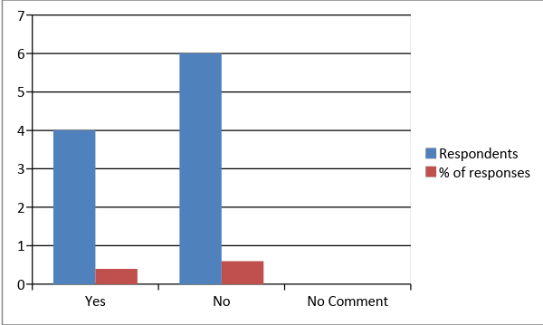

Figure 3 - Are the staffs and the attendants are morally sound?
As it is very evident from the aforementioned metric that the majority of the respondents convey that there lie serious moral issues in the organizational premises of Al Ain Hospital, this is further consolidated by the demeanor that the organizational executives does not even seem bothered regarding the feedbacks that the customers are prone to dispense(AL AIN, 2017).
Q2 Does the organizational executives appear aware and bothered about the harsh behaviors that the respondents are prone to dispense?

Responses | Respondents | % of Responses | Total Respondents
Yes | 2 | 20% | 10
No | 6 | 60% | 10
No comment | 2 | 20% | 10

Table 3 - Does the organizational executives appear aware and bothered about the harsh behaviors that the respondents are prone to dispense?

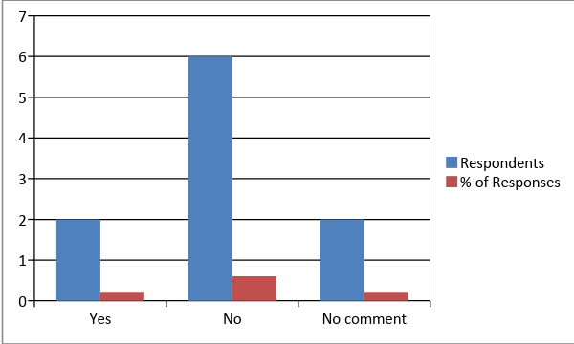

Figure 4 - Does the organizational executives appear aware and bothered about the harsh behaviors that the respondents are prone to dispense?

It is very evident from the aforementioned metric that equal number of respondents appear reluctant regarding the intent of the enquiry but the majority of the respondents is confident about the fact that the management of the respective health care unit does not care about the feedback since they does not have the courtesy to respond to them.
Q3 Does the organization maintain any alumni of the customers?
Responses | Respondents | % of Responses | Total respondents
Yes | 0 | 0% | 10
No | 10 | 100% | 10
No Comment | 0 | 0% | 10

Table 4 - Does the organization maintain any alumni of the customers?

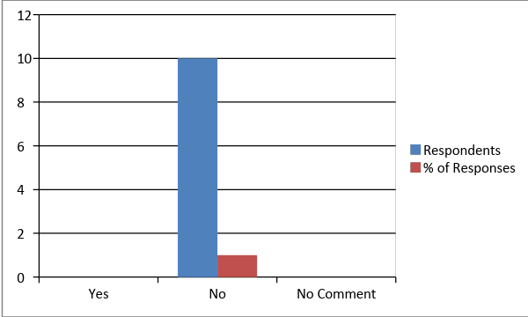

Figure 5 - Does the organization maintain any alumni of the customers?

This is very evident from the above mentioned metric that all of the respondents have vehemently disagree about the humanitarian aspects of the organization since they does not even bothered to keep an alumni of the patients that they have served.
Q4 Do the subordinates of the respective organization are responsive to the specifications of the patients?
Responses | Respondents | % of Responses | Total Respondents
Yes | 9 | 90% | 10
No | 1 | 10% | 10
No Comment | 0 | 0% | 10

Table 5 - Do the subordinates of the respective organization are responsive to the specifications of the patients?

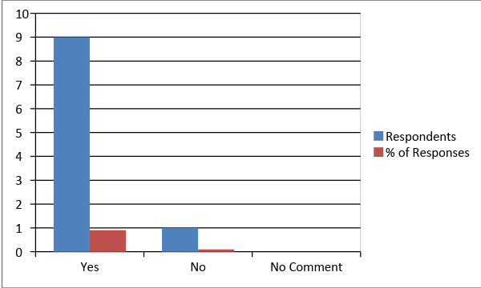

Figure 6 - Do the subordinates of the respective organization are responsive to the specifications of the patients?

It is very evident from the aforementioned metric that the accusation of pursuing a moral grudge that are mostly directed towards the patients are potentially wrong in terms of the responses that the subordinates are prone to dispense regarding the patients.
Q5 Do the organization diagnoses the maladies with prudence?
Responses | Respondents | % of Response | Total Respondents
Yes | 9 | 90% | 10
No | 1 | 10% | 10
No comment | 0 | 0% | 10

Table 6 - Do the organization diagnoses the maladies with prudence?

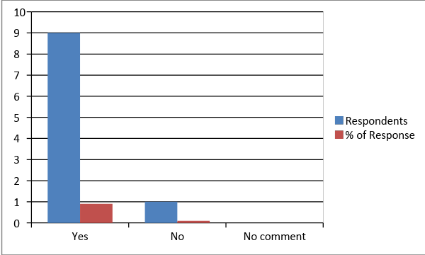

Figure 7 - Do the organization diagnoses the maladies with prudence?

This is very evident from the aforementioned metric that the subordinates are very efficient in terms of the tasks that they are appointed for.
Q6 Do they communicate with sincerity and compassion?
Responses | Respondents | % of Responses | Total Respondents
Yes | 1 | 10% | 10%
No | 8 | 10% | 10%
No comment | 1 | 10% | 10%

Table 7 - Do they communicate with sincerity and compassion?

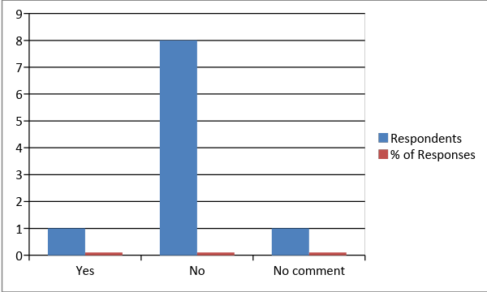

Figure 8 - Do they communicate with sincerity and compassion?

It is very evident from the aforementioned metric that the majority of the responses exhibit a sheer denial of the subordinates of the Al Ain Hospital being empathetic and compassionate.
Q7 Do they listen and respond to your pleas empathetically and compassionately?

Responses | Respondents | % of Responses | Total Respondents
Yes | 4 | 40% | 10
No | 5 | 50% | 10
No comment | 1 | 10% | 10

Table 8 - they listen and respond to your pleas empathetically and compassionately?

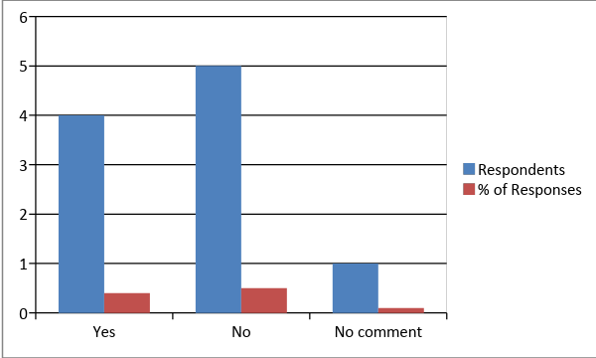

Figure 9 - they listen and respond to your pleas empathetically and compassionately?

It is very evident from the above-mentioned metric that the majority verdicts in favor of the underlying issue, though there lay a considerable dimension of reluctance regarding the opinion.
Q8 Do they care for your ethnic and cultural inclinations while being treated?
Responses | Respondents | % of Responses | Total Respondents
Yes | 3 | 30% | 10
No | 6 | 60% | 10
No comment | 1 | 10% | 10

Table 9 - Do they care for your ethnic and cultural inclinations while being treated?

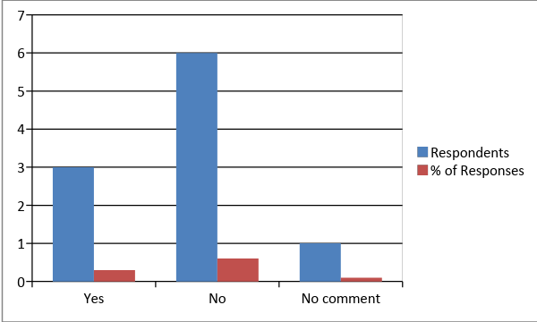

Figure 10 - Do they care for your ethnic and cultural inclinations while being treated?
It is evident from the above responses that majority of the patients feel that the patient care providers of the Hospital do not value their ethnicity and culture enough.
Q9 Are they professionally sound in terms of their mode of service providing?
Responses | Respondents | % of Responses | Total Respondents
Yes | 5 | 50% | 10
No | 3 | 30% | 10
No comment | 2 | 20% | 10

Table 10 - Are they professionally sound in terms of their mode of service providing?

Figure 11 - Are they professionally sound in terms of their mode of service providing?

The majority of the responses indicate positive attitude of the patients towards the service providers. Hence, it can be stated that the service of the hospital is sound enough to impress the patients.
Q10 What is their response towards the enquiry of the parents of the patients?
Responses | Respondents | % of Responses | Total Respondents
Very good | 4 | 40% | 10
Good | 4 | 40% | 10
Poor | 2 | 20% | 10

Table 11 - What is their response towards the enquiry of the parents of the patients?

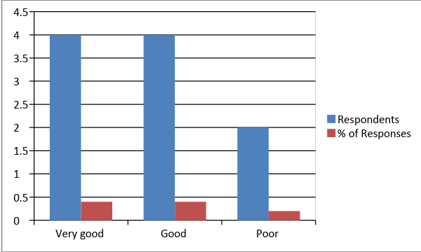

Figure 12 - What is their response towards the enquiry of the parents of the patients?

The data collected from this particular enquiry shows a mixed reaction of the patients. Therefore, no concrete conclusion can be drawn from the responses.

4.2 Contribution of the Project
This can be addressed that the moral issues that are emerging in the Al Ain Hospital can be seen in the premises of any other similar concern. On that note, it can be conveyed that the underlying project has been able to elevate the issue as a paramount violation of the humanitarian liabilities that the staffs are endowed with(Valenzuela, 2015). Moreover, from an aspect intensive to management this project suite is supposed to portray relevant issues that the potential customers are typically seek and how the effectiveness of the responses can be improved in order to retain the customer loyalty in order to acquire the desired sustainability(Lee & Cranage, 2012). Furthermore, this report suite might be conveyed as a manifesto of awareness that might prevent similar concerns to cultivate their harsh demeanor towards an intolerable extreme.

4.3 Limitations
The major limitation of the research suite is the apprehensions that it is supposed to dispense is fundamentally framed upon the primary data which is nothing but the cumulative responses of the major respondents of the questionnaire. However, this research suite is dedicated to abide by the ethical consideration that is framed upon the Data Collection Act, the researcher owns a considerable suspicion regarding the legitimacy of the data since the organization are prone to condition their potential patients. Furthermore, since the majority of the patients are still in their phases of therapy, it can be expected from them that they will morally restrict themselves to utter the ground level reality for the sake of their individual treatment.

4.4 Recommendations for Further Development within the organization
- It is very evident from the entire study that the moral impulse of the underlying suite is to eradicate the dimension of moral grudge from the instinct of the subordinates of the Al Ain Hospital that might offer them a wider customer base.
- Since the concern of the underlying study is to recommend the organization to develop their organizational demeanor, the management can be suggested to pose greater attention towards the feedbacks of the customers.
- That is something they need to impart attention at in order to retain the competitive edge while providing quality and technologically sound way of life.
- The Al Ain hospital can be recommended to introduce gift culture in the workplace premises in order to encourage the enhancement of the moral aspects.
- The subordinates need to endorse the cultural-specific inclinations and specifications of the respective patients that might enhance the moral aspects of the respective subordinates.

Chapter 5: Conclusion

5.1 Summary of the Overall Result
The main results and the details of the analysis have revealed that nearly all of the participants unanimously agree that listening to, and heeding, the complaints and negative feedbacks provided by the targeted customers (the patients and their relatives) and acting upon them is indeed the best way of overcoming the existing limitations and weaknesses of the organisational way of functioning. They also agree that providing better services helps in the reduction of the number of complaints as well. Indeed, the problems and issues such as the lax behaviour displayed by some of the staff members can be mitigated by the implementation of proper standards of discipline and a proper level of monitoring of the staff members. The complaints have to be heeded in order to know about the existing shortcomings, with even more effective services being possible as a result of the same. Indeed, effective services have been observed to have a deep effect on the responses provided by the customers (in this case, the patients), with the implementation of the former being instrumental in the reduction of the number of complaints and negative feedbacks (Gu & Ye, 2014).

5.2 Main Lessons Learned
- The main lessons learned in this study have included the fact that the feedbacks provided by the customers as well as the ways in which an organisation responds to the same are the main determinants of the success and the amount of customer loyalty that they can inspire.
- Trainees generally receive internal support from the hospital in a satisfactory manner, with the support from the internal and external stakeholders as well as the academic advisor being very helpful in this regard as well.
- This experience has been valuable in the personal development of the ability to conduct relevant analysis and studies of this nature, as well as the development of a level of understanding pertaining to the relationship between effective services and customer responses.
- The process has been conducted in a smooth manner, though the lack of a very large sample size has been an area of concern.
- A better sample size and a higher scale of a study of this nature can prove to be beneficial for future studies of this kind.

