Q.1.
a)
Ans- Opportunity cost is the cost of an opportunity foregone [Stephen A. Spiller (December 2011)]. In simpler words, when there are multiple alternatives available of doing a task and the best alternative is chosen as per the requirement, opportunity cost means the profit lost on the alternatives not chosen.
E.g.- Currently I have been looking for a job change. Last week I had 2 interviews set up on the same day at two very far-off locations. I knew I could only make to one of those interviews, so I had to choose the one I am more interested in. Hence, the opportunity of getting selected in the other company was the opportunity cost which I borne to appear in the interview for the company I was more interested in.

b)
Ans- In a normal scenario, the demand and supply diagram of a product in a market is as shown below John A. Dutton (2016) -

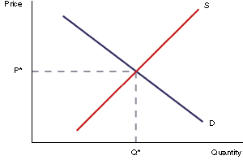

As we can see, the above diagram represents a situation when the demand and supply of a product is at equilibrium in the market. S represents the supply curve, D represents the demand curve, P^ is the equilibrium price and Q^ is the equilibrium quantity.

- If the price of solar panels falls to below the market equilibrium price- As per the demand function- lesser the price, higher the demand. And as per the supply function- lesser the price, lesser the supply. Hence, quantity demanded will be higher than quantity supplied which will create a shortage of solar panels in the market. [Pricing in Competitive Markets (2012)].

This can be diagrammatically explained as follows--
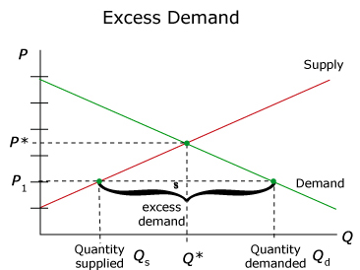
Interestingly, in an ideal economy a market doesn’t stay at non-equilibrium for a long time. So, after there is a situation of excess demand, the price will again start to rise. Hence, suppliers will start producing more to earn more profits. After a while, the quantity supplied will increase until it becomes equal to quantity demanded and market will again settle at an equilibrium with the equilibrium price P*.
- The price of electricity for an average household has increased by 50 percent – Increase in household expenditure indicates increase in standard of living. This implies that the existing consumers will demand more and there will also be an additional demand from new customer base. Hence, the overall quantity demanded for solar panels will increase [Market equilibrium (2012)].
The impact of this increased demand on equilibrium will be as follows -
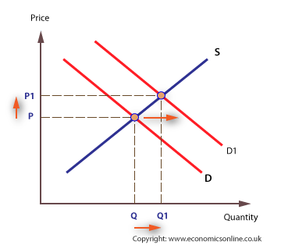
With increase in demand, there would be an increase in the equilibrium price will increase which in turn would encourage producers to produce more and hence increase the equilibrium quantity of solar panels will increase

Q.2.
a)
Ans- As per the Law of demand [Michael Jerison & John K.-H. Quah,-2006], every other factor being status quo (constant), if the price of the product increases, its quantity demanded decreases, and vice-versa. Demand has an inverse relationship with the price of the product.
In the given scenario, Granny Smith apples have decreased in price due to a very good harvest. This means that due to the increased production of the apples, the price has dropped in the market. Generally, Granny Mae used to buy 1 kilo of apples per week but due to decrease in price she bought three kilos from her favourite fruit store. This supports the law of demand, i.e. with decrease in price, the demand of the apple increased.
Let us assume initially the price of apple was $10 per kg and later it dropped to $5 per kg.
Price | Quantity
10 | 1
5 | 3

Diagrammatically, this can be represented as-

In the above diagram, DD represents the demand curve, with price on the X axis and quantity demanded on Y axis.

b)
Ans- Change in preference is an other than price items which affects the demand of the product with or without any change in the price factor. Law of demand fails to operate in this situation.
In the given scenario, Granny Mae saw the latest walking frame at a shop and they had the one which was very popular and in trend. All her friends were using the walking frame. She who was earlier of a preference to buy a regular walking stick, decided to buy the walking frame instead. This shows a change in preference of Granny Mae due to change in market trends. [Changes in Supply and Demand (2009)]
This can be diagrammatically represented as below-
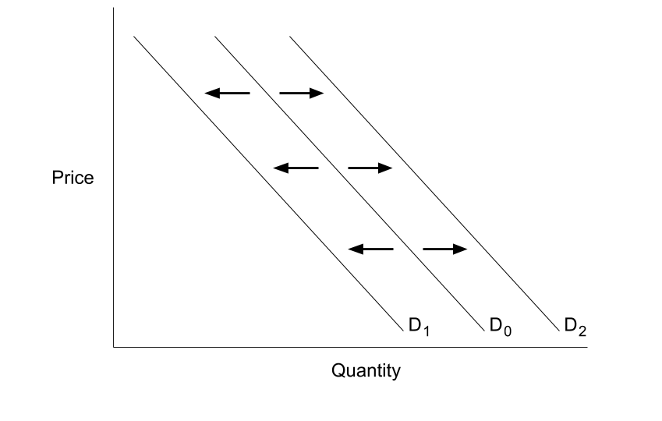
In the above diagram, Do represets the initial demand curve for both the products – walking stick and walking frame. Wih change in preference, the demand curve of walking stick has shifted towards the left to D1, which shows a decrease in quantity demanded with no change in price.While the demand curve of walking frame has shifted towards the right to D2, which shows an increase in quantity demanded with no change in price.
c)
Ans- The demand for normal goods or inferior goods depends upon the income and purchase power of the consumer. Whenever there has been an increase in consumer’s purchasing power, he shifts from inferior to normal goods and vice-versa.
In this scenario, Granny Mae’s purchasing power has increased because of an increase in her pension. This made her shift from inferior goods (walking stick) to a normal goods (walking frame).
Q.3.
Ans- The reduction in apartment prices in the capital cities of Melbourne and Sydney is mainly due to an increase in new apartments into the market, which implies that supply of apartments is much greater than the increase in the demand for new apartments.
As per the demand function- lesser the price, higher the demand. And as per the supply function- lesser the price, lesser the supply. Hence, quantity supplied will be higher than quantity demanded which will create an excess of unsold apartments in the market. [Pricing in Competitive Markets (2012)]. This can be diagrammatically represented as-
.
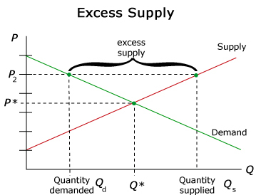

Q.4.
Ans- Keeping all the other factors constant, when the demand for yoga service has increased. However, the government has also introduced strict regulations that have resulted in a fall in the number of yoga service providers. Due to this decrease in the number of yoga providers, the supply of yoga will decrease, so the equilibrium price of yoga services will increase.
Interestingly, price is not the only factor of change here, but the supply has also decreased due to other than price factor i.e. strict regulations. The equilibrium quantity of yoga services may increase, decrease or not change because even with increased prices not every person can get legal permissions to provide yoga services, due to strict regulations, even if they want to be a service provider [Demand and Supply Analysis, 2010].
Diagrammatically this can be explained as-
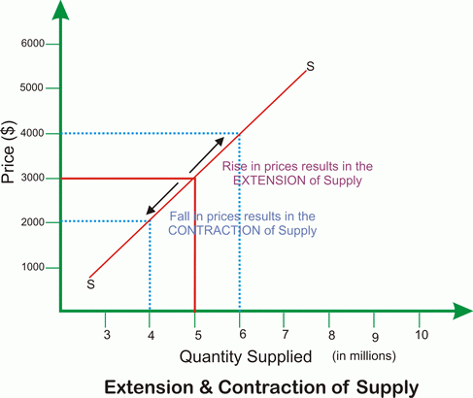

Due to change in other than price factors, the supply curve will move upwards or downwards on the same supply curve and effect the price accordingly.
If new suppliers enter in the market because of high opportunity to earn profits and with a valid permit to provide yoga services, the supply will increase. If existing suppliers exit in the market due to strict policies, the supply will decrease. If no new suppliers enter or none of the existing suppliers leave, there won’t be any increase or decrease in supply.

Q.5.
a)
Ans- Price elasticity of demand is setting the price of the product taking in consideration the sensitivity of product’s demand among customers with change in price. This concept is also known as demand elasticity [Price Elasticity of Demand [Nov. 13, 1997]. As a business owner, it is a very important strategic decision to set the right price of the product as per the elasticity, market trends and price of the competitor’s product.
Following are the signs of how elastic your product is-
- If demand of your product is not at all affected by the price changes, then the demand is perfectly inelastic. The Price Elasticity of Demand = 0 in this case. This generally occurs in the case of monopolistic market.

- If demand of your product is slightly affected by the price changes, then the demand is less than inelastic. The Price Elasticity of demand ranges between 0 to 1 in this case. This generally occurs in the case of oligopolistic market.

- If demand of your product changes in proportion to the price changes, then the demand is called perfectly elastic. The Price Elasticity of demand is 1 in this case. This generally occurs in the case of perfect competition market.

- If demand of your product changes drastically with the price changes, then the demand is called perfectly elastic. The Price Elasticity of demand is greater than 1 in this case. This generally occurs in the case of price sensitive market.
b)
Ans- The decision of the Western Australian government to set a minimum price on alcohol in order to minimize the risk of alcohol related illness may not work with all strata of society or with consumers from different social and financial background. [THE WESTERN AUSTRALIAN ALCOHOL AND DRUG INTERAGENCY STRATEGY [2017-2021].

The above diagram explains that due to a minimum price on alcohol-
- People who are addicted/ financially privileged – No change in demand
- People who are not addicts/ middle class income- Change in demand as per the price
- People who are occasional drinkers/ not so financially well-off- Drastic shift in demand as per price
Depending upon the situation mentioned above, there can be increase/ decrease or no change in quantity demanded of alcohol [THEORY OF DEMAND (January 2017)].

Q.6.
a)
Ans-No barriers to entry or exit of firms is a feature of a fair or perfect competition market. As we know that in a perfect competition market, the firm acts a price taker and not the price maker [Prateek Agarwal (Dec 5, 2017)]. Hence, there is no option available to the firm to decrease the price because the firm is already charging a fair share of normal profit margin on the product.
So the only option available to the firm if it is incurring losses in short term is to increase its scale of production and decrease the cost of production so as to earn profit without decreasing or increasing the Sale price.
b)
Ans- We are assuming that the industry has no barriers to entry and exit.
- If the firms operating in the industry are making abnormal profits- If there is an increase in demand in an industry, there would be an increase in sale price accordingly. The firms from another industry will be attracted to enter in the industry to earn more profits. With entry of more and more firms in the industry, the supply of the product will keep increasing and become equal to demand at some point. Hence, the sale price will fall down to the level of “cost + normal profit margin” and the industry will touch the breakeven point again and start making normal profits.

- If the firms operating in the industry are making abnormal loss- If there is a decrease in demand in an industry, there would be an decrease in sale price accordingly. If the existing firms in the industry will get discouraged and will try to exit the industry to minimize the losses. With exit of more and more firms from the industry, the supply of the product will keep decreasing and become equal to demand at some point. Hence, after sometime the sale price will rise up to the level of “cost + normal profit margin” and the industry will touch the breakeven point again and start making normal profits.

It can be diagrammatically explained as-

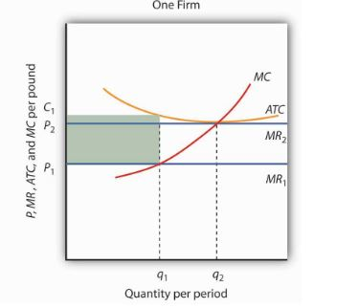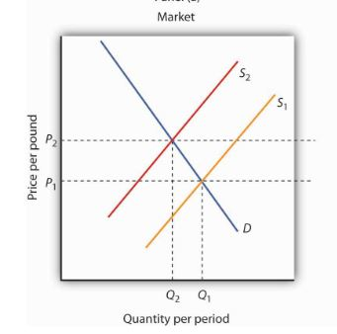

In fig. 1, the market price P1 is below ATC. In fig. 2, at price P1 a single firm produces a quantity q1, assuming it is at least covering its average variable cost. The firm’s losses are shown by the shaded rectangle bounded by its average total cost C1 and price P1 and by output q1.
After some of the firms exit. The supply curve in Fig.2, shifts to the left, and it continues shifting as long as firms are suffering losses. Eventually the supply curve shifts all the way to S2, price rises to P2, and abnormal profits return to zero. [Principles of economic (2017)].

