Assignment
Meta Title: Impact of UK’s withdrawal from EU on regulatory changes and FDI
Category: Business
sub category: International Business

BUSINESS REPORT
STUDENT NAME:
SUBJECT NAME:
STUDENT ID:
PROFESSOR NAME:

Executive Summary
The UK is the first country to withdraw from the EU. The impact of withdrawal will depend on the relationship between the EU and the UK. Due to economic changes in the country, various issues have been raised in the organisation. The report focuses on addressing two key issues such as foreign direct investment and regulatory changes. To mitigate the risk factors, the organisation can take advantage of the weakening of the EU to get access to other markets and standardise their policies in order to cope up with the changes.

Table of Contents
1.0 Introduction 4
2.0 Discussion of Key Issue 1 4
3.0 Discussion of Key Issue 2 5
4.0 Conclusion 6
5.0 References 8

1.0 Introduction
The process of withdrawal of United Kingdom from the European Union (EU) is known as Brexit. An advisory referendum was held in June 2016, where 52% votes were cast for leaving the EU. Thus, the government of the UK would invoke the process of withdrawal by the end of March 2019. Due to this withdrawal, there is both long and short-term economic impact of the business sectors of the UK (Cer.org.uk, 2014). Gifford (2010) stated that Brexit would have an impact both the position of the UK and The EU in the world with little prospect for the business sector to grow. However, the impact depends on the future relationship between the EU. The focus is to discussion the key issues on foreign direct investment and financial services. The key stakeholders of the report are organisations that will be affected due to Brexit. The reports highlight two issues created due to Brexit, the opportunities and problems that the business need to face. It also recommends few measures to mitigate the problems.

2.0 Discussion of Key Issue 1
The first issue that the business will be facing is the UK oil trade. The factors that need to analyse is related to foreign direct investment. Due to the impact of Brexit, the UK becomes less attractive as a gateway to Europe. Due to the withdrawal, it is no longer the corporate headquarters of European Union's. Because of which, the organisation finds it difficult to relocate its business from the UK. Strumia (2016, p.110) stated that the issue of foreign direct investment is concerning because it has is the most important source of fund for the business sector. It is important as the effect of Brexit can pose a risk where the UK can attempt to attract FDI by undercutting the standards of EU.
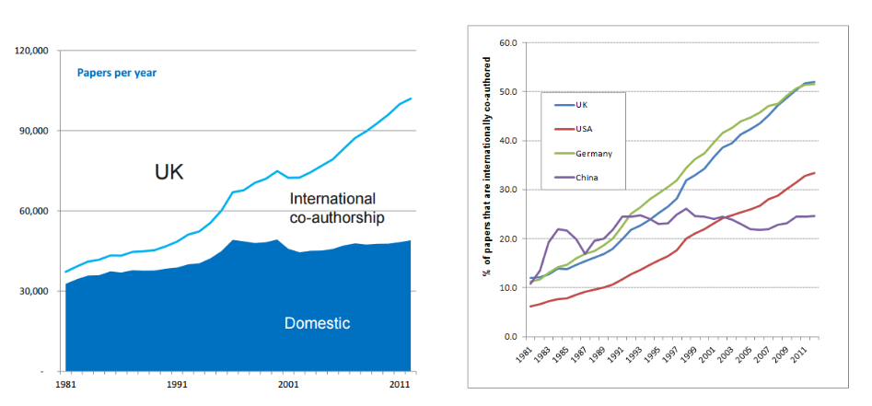
Figure 1: The UK’s increase output predicted after Brexit
(Source:Blogs.lse.ac.uk, 2015)

The opportunities that are created in accordance with the UK oil trade is it gain flexibility over policies in oil industries and it also weakens the competitive edge. Since the oil industries will be operating at freedom, it will have all the powers to act accordingly and attract foreign direct investment on its own term. Thus, the business sector of the UK gains financially; however, it depends on the model and variation on the economy of the country. The problems that the business will be facing in due course of time are political contagion and loss of liquidity. Weiler (2015, p.5) opined that the cost of financial services will also increases which will decrease the profit margin of the organisation. Due to shift in balance in the European Council, it will become harder to form a blocking minority against the illegal measure. It also important for the organisation to be concern about the EU trade matter as the UK will feel the effect of Brexit.

3.0 Discussion of Key Issue 2
The second issue that the organisation will be facing due to the withdrawal of the UK from the EU is a trading system within Europe will affect the business sector. The policies and procedure will be changing because of which there will be a regulatory divergence. The regulatory divergence will grow with time and it will have an impact on the trading system. Barrett et al. (2015, p.24) commented that the increase in the cost of trade will influence volume and position of UK in the supply chain. The country will lose all its power in regards to the regulatory system. Thus, it loses the freedom to regulate independently. The prospect of immigration will be tightened due to Brexit. This will damage the competitiveness of companies, particularly in London.
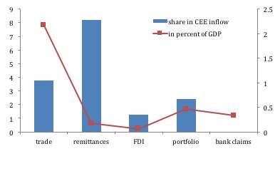
Figure 2: Effect of Brexit on European Union
(Source: Blogs.ucl.ac.uk, 2015)
The UK companies will retain the competitive edge over other countries however; the companies will find it hard to trade in the European market due to the withdrawal. The opportunities that will occur due to the impact of Brexit are the policies of the EU will be weakened which can be taken advantage and impacts will be on public procurement. Due to the impact, many countries that are the party of the EU will be affected. The effect will be due to diverting or remittances migration and the extent of political contagion cannot be predicted. This is advantage for the organisation as the demand of such countries can be meeting (Cumming and Zahra, 2016, p.690). The EU becomes a less attractive partner for trading and the political weight is being reduced. This will be advantageous for the organisation as it can extend its business and have an international influence. This highlights that the organisation have an opportunity to grow well in this setting off changes, however, the changes that will occur cannot be predicted at this moment thus, the effect on the organisation is hard to evaluate.

4.0 Conclusion
The report highlight that the impact of Brexit on the organisation of the UK. The impact occurs in terms of regulatory and economical. The position of both the UK and THE EU will be affected in the due course of time that will have little control. The key issues that are being discussed in relation to Brexit are a change in the regulatory framework of the organisation and issue related to foreign investment. The effects have both positive and negative effect on the organisation. The organisation needs to standardise the policies to get access to a market of different countries and take advantage of the weakening of the EU to develop a base for foreign direct investment.

5.0 References
Barrett, A., Bergin, A., FitzGerald, J., Lambert, D., McCoy, D., Morgenroth, E., Siedschlag, I. and Studnicka, Z., (2015). Scoping the possible economic implications of Brexit on Ireland. ESRI Research Series, 48(1), pp.1-73.
Blogs.lse.ac.uk, (2015) Debunking the myths about British science after an EU exit Available at: http://blogs.lse.ac.uk/brexit/2015/12/05/debunking-the-myths-about-british-science-after-an-eu-exit/ [Accessed on 10 Nov, 2016]
Blogs.ucl.ac.uk, (2016) Brexit threatens Europe's mission Available at: http://blogs.ucl.ac.uk/ssees/page/2/ [Accessed on 10 Nov, 2016]
Cer.org.uk, (2014) The economic consequences of leaving the EU Available at: https://www.cer.org.uk/sites/default/files/smc_final_report_june2014.pdf [Accessed on 10 Nov, 2016]
Cumming, D.J. and Zahra, S.A., (2016). International Business and Entrepreneurship Implications of Brexit. British Journal of Management, 27(4), pp.687-692.
Gifford, C., (2010). The UK and the European Union: dimensions of sovereignty and the problem of Eurosceptic Britishness. Parliamentary Affairs, 63(2), pp.321-338.
Strumia, F., (2016). Brexiting European Citizenship through the Voice of Others. German Law Journal, 17(1), pp.109-115.
Weiler, J.H., (2015). Brexit: No Happy Endings; The EJIL Annual Foreword; EJIL on your iPad!!!; Vital Statistics; ICON. S Conference. European journal of international law= Journal europeen de droit international, 26(1), pp.1-7.

