MARKETING ASSIGNMENT

Introduction:
Marketing strategy is the most important process in the organization as by the help of strategy and this formulation of strategy will help to capture the mind of the customers moreover the organization will gather possible consideration from the market and then will gain profitability from the market (Johanson, & Mattsson, 2015). The strategic process will further include market analysis, market selection, marketing mix and customer acquisition. In this study, the case evolves with the possibility that the organization will do proper market research its use in a marketing plan, analysis of the competitive strategy, PESTEL and SWOT analysis will help to gather possible information about the company.

Analysis of market Research and its use in a marketing plan:
In the process of Market research is the, it is basically comprises of collecting information about the market of particular organization, customers and competition in consideration to the global market. Further, it will assist the marketer to absorb more information about the people whom the organization wants to sell the product or service to acknowledge the fact that they are going right in the market and can able to fulfill the need of the customers, specially collecting the data about customers’ preferences (Wei, Samiee & Lee, 2014). It will permit the organization to recognize and inspect the market want and need, size of the market most importantly taken into consideration the other competitors in the market. This process is helpful to regulate the practicality of the organization’s product or service moreover recognizes the procedure to promote organizational product or service, and expand a competitive strategy so that they can increase the competencies in the market and serve best things to the customers (Hays, Page & Buhalis, 2013). The Market research Plan and implementation is favorable at any phrase in a business, but sometimes it is very much condemnatory and critical for new start-ups in the market. The marketers who have started new businesses require demonstrating that there is an eventual market for their product and service before starting the business as a new comer and the customers need to know about the products. The information accumulate from conducting market research will nourish in the number of segments when planning and implementing the business plan (Sarstedt et al. 2014). However, the marketing plan will help to gather data and information regulate the organization’s sales potentiality, identification of the target market’s demographic and economic profile, choose a suitable business location and in accordance to that, the management will plan up for the price. The organization’s market research will also abet the management and marketers in enlarging marketing procedure for the business.

Analysis of the competition for a product:
An extensive investigation process and inspection of the organization’s competition will authorize to evaluate competitor’s strengths and weaknesses in global marketplace and assist the marketers to select and contrivance the efficient and effective strategies that will help to stimulate and upgrade competitive advantage in the market. Before starting the business the organization needs to look up to, the products and services that it wants to sell moreover the products and the services require being different from others already in the market. There is a broad product segregation offered by Apple Inc. (AAPL) and the company faces some strong competitor in several industries, differs from personal computers to media related to entertainment other than that the mobile payment systems. Here is a list of the technology giant's main competitors by industry (Du, Chen, & Tsai, 2016). In personal computer section Apple faces competition from Dell, Acer and Lenovo as Apple has their loyal targeted customers so the company always needs to serve best things to the customers in order to maintain their market positioning. In mobile computers Apple business model and the entire industry has some imitators as if Nokia, Samsung and Google but still Apple maintain a position as a profitable company (Besbes & Sauré, 2016). Most importantly, the smart phones that Apple launches has high value in the market and the competitors are Samsung, Song, Lenovo, HTC etc and Apple follows intensive research and then they offer things to the customers. The entertainment media and applications in Apple and Google have taken the initiative to serve best things to the customers. The operating system that other company uses also taken up several steps to catch the attention of the customers (Carlton & Winter, 2014). The play stores permits to get the media, entertainment and books. Apple also introduces mobile payments, they take the regards of competitors’ analysis, and the key competitors in the mobile payment industry incorporate Google and Paypal.

Analysis of PESTLE and its affects the introduction of a new products or services:
PESTLE, which stands for political, economic, sociological, technological and legal factors to consider with the management criteria of any specific organization. The organization use PESTLE when it needs to launch a new product or service, entering a new region or country, considering a new route to the market to view the products and services and working as part of a strategic project team (Pestle et al. 2014). The company needs to check up various possibilities for the products and the services that the organization need to check up.
Political factors - Both big and small 'p' political intensity and impact that can affect the performance of or the alternative open to the organization and the political factors will help the organization to shape up things in more proper way as they will get support (Zalengera et al. 2014). The political factors will include ecological or environmental issues, current legislation home market, future legislation, regulatory bodies and processes, government policies, government term and change with consideration of products and services, international pressure groups.
Economic influences - The creation of the competition overlook by the organization or its services, and financial resources obtainable within the economy. In this factor the home economy situation, home economy trends, overseas economics and trends, customer drivers, interest and exchange rates and taxation specific to product and services (Singh, 2016). The products, which are selling themselves in the market, will help to process things in international trade and monetary issues as the products need to introduce themselves in the market.
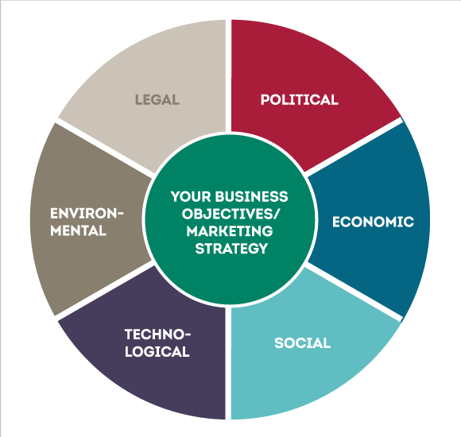
Figure 1
(Source: Singh, 2016, p. 1265)
Sociological trends - Demographic changes in the area, trends in the process people live, work, and think, the life style trends, consumer attitude and changes, law changes affecting social factors related to the brand from that the product belongs to enhance the technology, consumer buying patterns (Pestle et al. 2015). The fashion and the role model will help for better access in the market with consideration to the ethnic and religious factors. Advertising and the publicity will help to get the appropriate information about the products and the services with relation to the ethical issues.
Technological innovations – The new resemblances to proceed towards new and old things, and determined new and old problems; these do not essentially require technical equipment and that will help in better product orientation and other things will do in a proper manner (Akca & Albeni, 2014, May). The technological advancements will help the product to reach out to the customers in easy way and the customers will be happy with the products. The manufacturing maturity will help for better capacity in the products because the innovation potentiality will increase. The maturity of the technology will further help for the consumer buying process and the customers will satisfied with the products.
In the organization, the PESTEL analysis will help in create a good understanding about the products because the marketer will take the consideration of the decision making process and they will also involve the entire management for this process to acknowledge things in clear way and serve the valuable products to the customers.

Analysis of SWOT analysis and its use in the marketing plan:
The procedure of SWOT analysis assess the company's strengths, weaknesses, market opportunities and potential threats to furnish a competitive insight into the prospective and critical issues that influence the overall success of the business of the organization. Furthermore, the initial goal of a SWOT analysis is to recognize and allocate all essential factors that could positively or negatively impact success to one of the four classification, catering an objective and in-depth look at the organizational marketing and operational process.
Strength : An organization’s positive accredit internally help to bring possible success and cater control to the organization. Strengths often encircle organizational resources, competitive advantages that the organization has in the market, all the positive consideration of those within the organizational workforce and the other features associated to the business that the management do in a very particular way, concentrating on all the internal components that add value or provide the organization a competitive advantage (Islam & Mamun, 2017).
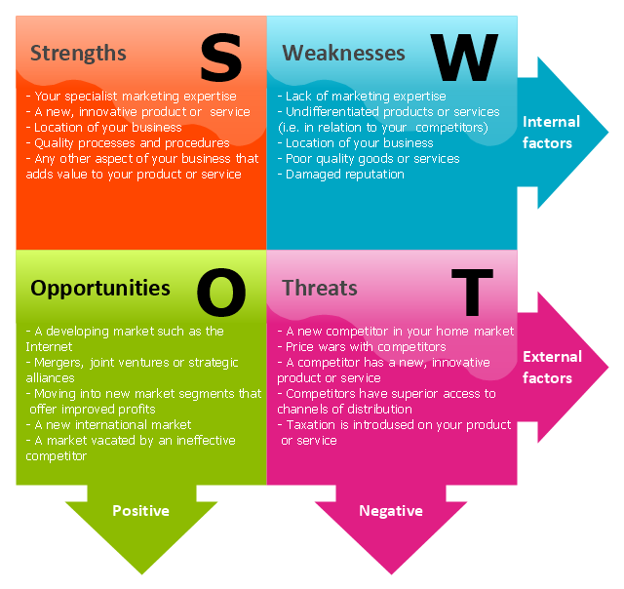
Figure 2
(Source: Shabanova et al. 2015, p. 705)
Weaknesses – The factors that are within the organizational control yet diminish from the ability of the operational process and the management to procure or encourage a competitive edge such as having a limited expertise, lack of resources, limited entrance to knowledge, skills or technology. The inferior services or a bad physical location can affect the business to a great extend (Shabanova et al. 2015). Weaknesses enclose the negative external and internal features to the business that decreases the entire value of the products or services offered.
Opportunities – The main thing related to the external factors that appointed the motivation for the business to prevail and flourish within the marketplace. Factors incorporate the particular and determined opportunities existing within market that cater a convenience to the organization, that includes certain market growth, changes in lifestyle, intention to solve the current problems or the basic capability to offer a potentiality. The value in the consideration to market competitors to promote an increase in demand for the products or services (Bull et al. 2015).
Threats – The external factors is not under control of the organization that have the prospective to place with reference to the marketing strategy and strategizing the plans for entire business at risk. The initial and existing threat can create competition. Furthermore, other threats can incorporate unsustainable price enlarge by suppliers, growing government regulation, the economic downturns, the negative coverage of press, transfer in consumer behavior or the establishments of "leap-frog" technology that leaves the organizational products or services outdated.

Analysis of segmentation, targeting and positioning in marketing (STP):
The essential part of the marketing policy can be followed with the help of the segmentation, target and positioning factors. It is the basically the influence of the marketers to innovate and create recognition of the organization products and services within the consumers. It is indispensable for the individuals to be perception of the brand’s existence and the brand will able to catch up the mind of the customers (Niederwieser et al. 2016). The USPs of the brands needs to be interface well to the end-user. Segmentation, target and positioning include the process for identification of customer needs, segment of the market cooperates with industry sector, geography, demographics and frequency of purchase, and later it will develop profits of the resulting segments. Targeting will evaluate the attractiveness value of each segment. Select the target segments include industry sector, geography, demographic and frequency of purchase and it will priorities resulting segments. Marketing planning develop for getting a better segmentation planning, market knowledge system, database and communication system (Xingang, Jiaoli, & Bei 2013). The last on is positioning that identify what is different about the product, service for each segment and it will formulate the marketing message for each segment of the market. Segmentation, target and positioning will view the geographic, demographic, psychographic and behavioral segmentation plan.

Analysis of new products or services launches or brand management:
Any company can adopt brand extension as strategy and it will focus to cater a certain brand value with the direct of gaining profit from the brand acknowledgement that attained in the current markets. a company launch new product with consideration to the customers preference and market under the products can fetch well-known brand name, failure in rates and marketing costs get deducted and in the market process more than 80 per cent of firms expedient to brand extensions as a process of marketing goods and services. The competition present in the market intensifies the organization to adopt new strategies that innovates a competitive advantage for the firm and by the help of this competitive advantage; the firm can do the business very well (Uhrenfeldt et al. 2014). Creating a brand name with well-established associations is one way of achieving this aim. Any organization invests heavily for the development of a brand. The process is very costly but has many returns from the business once success gets achieved by the organization. Brand extension connects with the marketing strategy and it has become even more attractive in recent environment where developing a contemporary product costs that initiates a lot of money and it can consume time. The innovation of new products needs proper implementation of things as the process need to follow some of the organizational process. The brand will create when the, marketer will take the initiative that the products can able to face the growth and attract the mind of the customers. For launching the new product, the organization needs to do appropriate brand management. The brand management will face various possibilities like sales force, IT systems, marketing communication, distribution, manufacturing, customer illustration, provisioning, procurement, accounts receivable and pricing channel.

Self-reflection:
I feel that in the market, the marketers and the management follow sustainability of the organization they need to strategize the plans so that they can able to maintain their position in the market along with that the organization by delivering best things to the customers can reach up to the desirability of the customers. By following this procedure it makes a considerate position in the global market scenario. By getting a good aspect in the products and the services, the organization can look into the process of existing competitors who are serving the need to of the customers. with the help of proper research the organization can able to penetrate the market in a way so that they can sell best things to the customers along with that the organization can earn profitability.

Conclusion:
The rapid changes in the market will help in proper progress and in accordance to the increasing level of competition; the organization is highly responsible for creating a good marketing base for the customers. Marketing activities is very much essential for the effective marketing strategy formulation.

