Question 1
The details of whether the following categories are PCBU or not according to the new WH&S act are listed in the following table. PCBU stands for “Person Conducting a Business or Undertaking’.
Description | Yes/No
Individuals who carry out domestic work in their own home (e.g. domestic chores etc. | No
A builder (including principal contractors and sub-contractors) | Yes
A government department or government agency | No
A manufacturing business | No
A nanny working in your home for your child. | No
Individual householders who engage persons to carry out ad hoc home maintenance and repairs or other domestic work, e.g. casual babysitters. | Yes
An owner-driver of their own transport or courier business | Yes
A school or college | No

Question 2
The risks from the given scenario are,
- The 3 year old son of Guy and Samantha may fell into the pool accidentally while playing.
- The dog may went out of the gate and fell into the pool.
- There may be security issues. Like someone may break into the house from that broken gate.
The risk matrix based on the identified risks are,
Frequency | CONSEQUENCE
 | Insignificant outcome | Minor outcome | Moderate outcome | Major outcome | Catastrophic outcome
Almost certain
Likely |  |  |  |  | Risk 1  As the baby does not know swimming.
Possibly |  |  |  | Risk 2  As the dog may manage to swim. | Risk 3  As it has catastrophic consequences like robbery, murder etc.
Unlikely
Rare

Being a real estate manager, I would handle this situation promptly and after the initial investigation I’d either fix the issue or I’d request the tenant to fix the issue by themselves and to adjust the expense with the rent later.

Question 3
The stakeholders of the project are,
- The aircraft engineers
- Suppliers who are also the end users
- Staffs who use the system to place orders. They are likely to be the engineers
In this case, ‘Us’ is the CEO of XYZ Airline. And ‘them’ is the suppliers who refused to use the system and the unions threated industrial action.
XYZ could have done the following risk assessment to avoid the failure,
- Checking the requirements of the system
- Talking to the stakeholders to understand what they want from the new system
- Quality control during the development and testing process. It would reveal the issue of late ordering during the testing phase and the system could be fixed.
- Taking some suitable risk management strategies and continuously monitoring the status of the risks and to keep checking whether there is any new risk raising from the project.

Question 4
The matching of the rows is given below. The left column contains the terms and the right column contains the descriptions of the terms.
- Stakeholder | Person involved in or affected by project activities
- Customer | People who will use the outcome of the project
- Consultant | Responsible for the technical ideas and advice
- Project Manager | Responsible for managing project activities
- Project Team Member | Person who work in the project

Question 5
Project management helps to bridge the gap between a project plan and the actual implementation of the plan. The purpose of project controls is to collect, analyze, and use data from the project management activities in order to make predictions about the outcome of the project. It also helps to understand the impact of time and cost constraints on the project. The formats of the data share and communication must follow standard procedure and format used for decision making and effective project management. The three project control methods are described below.
- Cybernetic Control
Cybernetic control is one of the widely used project control method. It is focused on the inputs and outputs of a project. Milestones are set across a project schedule to track the outputs during a project life cycle. Project inputs must help the process to generate the outputs and meet the deadlines specified in the milestones. During a project life cycle, project manager tracks the milestones to understand the project progress. If any outcome fails to meet a milestone, then investigation begins and suitable action is taken. It also helps to track whether the standards of an outcome have met or not at a milestone.
This is suitable for project where the requirements are clearly defined. For example, a project on setting up a restaurant can follow this kind of project control. Simplicity is the major benefit of the approach. However, it may lack standardization.
- Decision Based Control
The project control methods works on a decision making system to make a go/no go decision. It requires a project to meet or fulfill certain preconditions before undertaking a task. It can be applied on a partial area of the project schedule. Hence, the project is suitable for such ones where there are dependencies between tasks.
- Post-Performance Analysis Control
The controls are applied once the project is completed. Instead of focusing on what happened, the approach is to focus on making sure that there won’t be any such practices in future. This is suitable for project like building, home improvement etc.

Question 6
Tuckman’s 5 stages of team development have been described below in the context of the current project team building.
The stages are,
- Forming Stage
This is the initial stage of team building. The team members are introduced with each other and they can have a discussion on the project goal, schedule, rules and the skills, background, interests etc.
In the current project, the project manager was responsible to form the project team.
- Storming stage
During this phase, there may be conflicts among the team members. Hence, resolution requirement is very high. During such conflicting stage it is necessary to avoid confusion.
The storming phase was when the team members had some hot discussion on the roles and responsibilities.
- Norming Stage
The team member start noticing the strength of other team members. Hence, they start to settle down for the project. Once the storming phase is high, the team members settle done.
- Performing Stage
The team members performs their roles and fulfill the responsibilities. In the current project, the team members performed their roles in a satisfactory y way.
- Adjourning Stage
After completion of the project, the team members separate. Once the project will be completed, it will release the team members.

Question 7
The flowchart is given below.
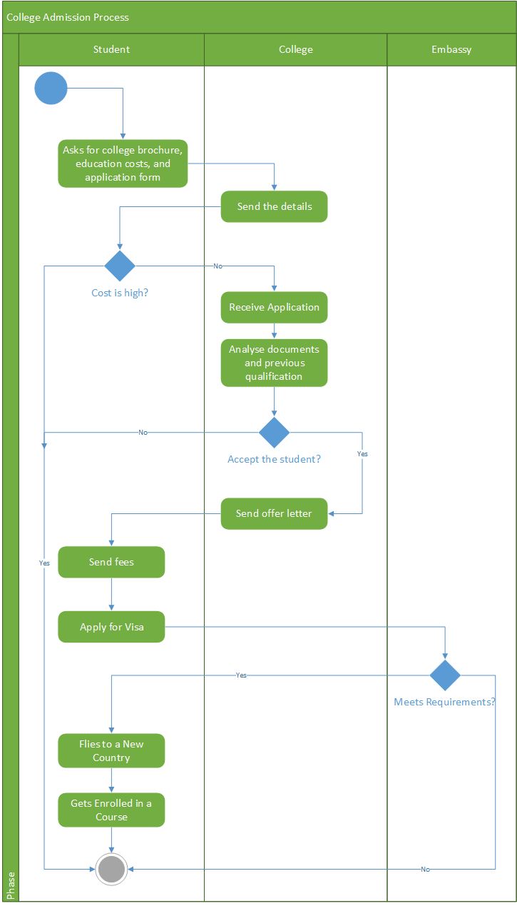

Question 8
- From the given information,
The average profit is = $\frac{\$(30000+50000+55000+60000)}{4}=\$48750$
The annual investment is, $200,000.
Hence, the accounting rate of return is, $\frac{\$48750}{\$200000}=24.4\%$
The advisor said 20% return per year, and the accounting rate of return is more than that. Hence, it is advisable to undertake the project.
- It is,
Payback period = $\frac{Investment }{Annual Cash Inflow}= \frac{60000 }{7000}=8.57 years$

Question 9
- As the company is in serious financial trouble but the project has already started so a suitable initial step would be,
D) Revisit the planning processes of project risk management to understand the upcoming risk in conjunction with the seller before any further decisions are made.
2. The loaded hourly wage is D) $29.12

Question 10
The network diagram is given below.
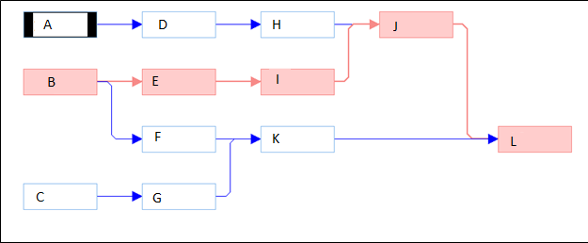
There are four alternative paths.
Path 1, ADHJL , duration is, 76 days
Path 1, BEIJL, duration is 78 days
Path 1, BFK L, duration is, 50 days
Path 1, CGK L, duration is, 50 days
The critical path is highlighted in red.

