MICROECONOMICS
Table of contents

Question 1 3
Question 2 3
Question3 6
Question 4 7
Reference List 8

Question 1
In microeconomics Price elasticity of demand is an important concept to understand consumer behavior regarding change in price. It shows changes that takes place in demand of a product with change in the price on particular product. Thus, it actually measures correlation between the changes in demand for a good in response change in price. In words of Miller and Alberini (2016), price elasticity of demand derived through the process of division among percentage change in quantity demanded with respect to percentage change in price. Elasticity, in short, is the measurement of the demand curve in response to price. It can be determined by several factors in the form of - a number of close substitutes of the good, nature of the good, that is whether it is luxury or necessity good, the proportion of a customer's income to be allocated for purchasing the good and so on.
As mentioned by Mason and Roberts (2018), price elasticity on supply of good shows relationship among changes in quantity supply with respect to change in price. The required formula needed to get price elasticity of supply is simply, “percentage change in quantity supplied divided by percentage change in price”. Price elasticity of supply depends on several factors such as marginal cost of production, factor mobility, available time, the output storage ability, excess supply and so on. If it is more than 1, then supply is price elastic in nature and if it is less than 1 supply is inelastic in price.
If a very small price hike can lead to a decrease in quantity demanded by a large amount, and small decrease on price leads huge increase quantity demanded, then demand is price elastic. On the other hand, if the quantity demanded does not change by large numbers due to change in price, that is price willing to be paid by consumers does not deviate too much from the average, then the demand is inelastic with price change. If the price elasticity more than 1, it implies elastic demand. On the other hand, if the calculated price elasticity is less than 1, it means demand is inelastic.

Question 2
The slope of the demand function measures the flatness or the steepness of its demand curve. This slope can be derived by dividing change in price by change in quantity. It measures absolute change in quantity with respect to an absolute change in price. As per Sleeman (2017), while measuring slope of demand curve the change in price and the change in quantity demanded is measured in the ratio form. An elasticity of demand, on the other hand, shows the percentage changes in price and quantity. Thus, when a price-quantity ratio is multiplied with the reciprocal of the slope of the demand function, elasticity of demand can be obtained. There is no such relation between these two, but it may occur that, two demand curves having same slope but different elasticity or the other way.
The slope of negatively-straight line demand curve is constant but if elasticity of demand is considered along with a negatively sloped demand curve, it changes at every point on the curve.

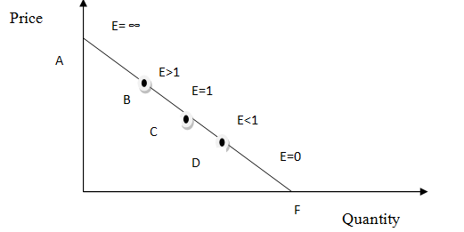

Figure 1: Negatively sloped demand curve
(Source: Influenced by Varian, 2014, p.66)
In this figure, it has been seen that at point A, the demand is perfectly elastic. At point B, the demand is elastic with respect to price. At point C, demand elasticity is equal to 1, implies it is unit elasticity. Point D indicates the inelastic demand and at point F, quantity demand is perfectly inelastic.

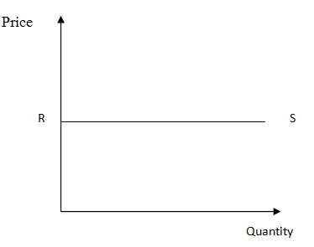

Figure 2: Perfectly Elastic Demand Curve
(Source: Influenced by Oikarinen et al. 2015, p.254)

Horizontal demand curve means demand is perfectly elastic to the effects of change in price. Here demand elasticity is infinite. As opined by Oikarinen et al. (2015), the slope of the curve is zero and it implies price cannot fluctuate in this type of market due to competitiveness and close substitutes. Number of sellers is large and they are selling same kind of products in the markets. In this context the example of coffee and tea can be explained. They both are same kind of drinks, so if the price of coffee is increased while the price of tea remains the same consumer can switch from coffee to tea.
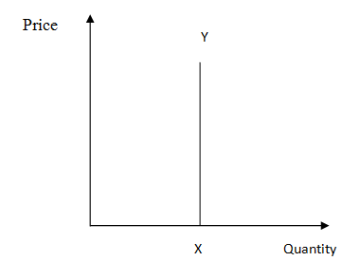

Figure 2: Perfectly Inelastic Demand Curve
(Source: Influenced by Becker, 2017, p.455)

Vertical demand curve means demand is perfectly inelastic in response to change in price. Demand elasticity is zero here. As mentioned by Becker (2017), slope of the demand curve is infinity in this case it implies no changes in demanded quantity with the price changes. Though most of the economists think this situation may not exist in real and happens in theories only.

Question3
Substitution of any good can be a key determinant of its demand elasticity. If the number of close substitutes of any good is large, then it is highly elastic in demand because consumers have greater options to choose from. People can switch to substitute if a small increase in the price level of a particular good occurs. In words of Chen et al. (2017), the greater the availability of close substitutes implies sensitivity of quantity demanded with respect to the changes in price. The demand elasticity of any product that has large numbers of substitutes is measured by the ratio of percentage change in demand of one good and the percentage change in price of its substitute good. This scenario may occur in competitive markets with similar products. On the other hand, the good with less number of substitutes has inelastic demand.
Elasticity of demand depends on -
- Nature of the product: Luxurious gods are more elastic compare to necessary goods.
- Income level: Consumers with low income level tend to have more elastic demand compared to high income groups.
- Substitute goods: As mentioned by Varian (2014), goods with large number of substitutes have more elasticity of demand.
- Price: Expensive goods rather than inexpensive have high elasticity of demand because their demand is sensitively related to their price change.
- Time period: In words of Friedman (2017), in short run demand is inelastic in nature but in long run demand is tend to be very elastic in nature, as consumers would then have a wider variety of options.

Question 4

The total revenue of a firm is measured by multiplying total quantity produced in the firm with the price level. Its calculations validate whether the demand is inelastic or not. As opined by Cowell (2018), if a firm raises its prices along with elastic demand of their product then its revenue decreases. It implies an increase in price can causes deduction in the total volume of quantity demanded and it can offsets the impact of rise in price or the per unit revenue increment. On the other hand, an inelastic demand for good along with the increase in price raises the total revenue of a firm. This implies that a rise in price can lead to reduction in volume of quantity demanded but not in large number and because of inelastic nature of demand the per unit revenue increases. Hence, a firm should change its price regarding the demand elasticity of its product.

