Network Diagram

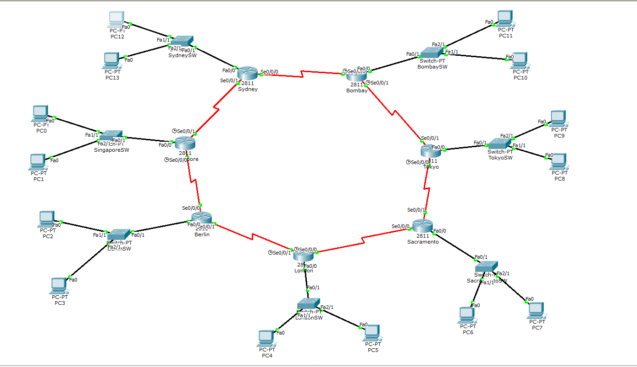
Subnet Allocation
Location: London (LD)
Number of IP Required: 495
Number of IP Allocated: 510
Network Address: 10.0.0.0
Subnet Mask: 255.255.254.0
IP Range: 10.0.0.1 to 10.0.1.254
Broadcast Address: 10.0.1.255

Location: Sydney (SY)
Number of IP Required: 450
Number of IP Allocated: 510
Network Address: 10.0.2.0
Subnet Mask: 255.255.254.0
IP Range: 10.0.2.1 to 10.0.3.254
Broadcast Address: 10.0.3.255

Location: Singapore (SG)
Number of IP Required: 190
Number of IP Allocated: 254
Network Address: 10.0.4.0
Subnet Mask: 255.255.255.0
IP Range: 10.0.4.1 to 10.0.4.254
Broadcast Address: 10.0.4.255

Location: Tokyo (TK)
Number of IP Required: 95
Number of IP Allocated: 126
Network Address: 10.0.5.0
Subnet Mask: 255.255.255.128
IP Range: 10.0.5.1 to 10.0.5.126
Broadcast Address: 10.0.5.127

Location: Sacramento (SC)
Number of IP Required: 77
Number of IP Allocated: 126
Network Address: 10.0.5.128
Subnet Mask: 255.255.255.128
IP Range: 10.0.5.129 to 10.0.5.254
Broadcast Address: 10.0.5.255

Location: Berlin (BR)
Number of IP Required: 55
Number of IP Allocated: 62
Network Address: 10.0.6.0
Subnet Mask: 255.255.255.192
IP Range: 10.0.6.1 to 10.0.6.62
Broadcast Address: 10.0.6.63

Location: Bombay (BB)
Number of IP Required: 27
Number of IP Allocated: 30
Network Address: 10.0.6.64
Subnet Mask: 255.255.255.224
IP Range: 10.0.6.65 to 10.0.6.94
Broadcast Address: 10.0.6.95

Interface Address Allocation
Device Name: LondonRouter
Interface Name: Fast Ethernet 0/0
IP Address: 10.0.0.1
Subnet Mask: 255.255.254.0

Interface Name: Serial 0/0/0
IP Address: 192.168.10.1
Subnet Mask: 255.255.255.252

Interface Name: Serial 0/0/1
IP Address: 192.168.10.5
Subnet Mask: 255.255.255.252

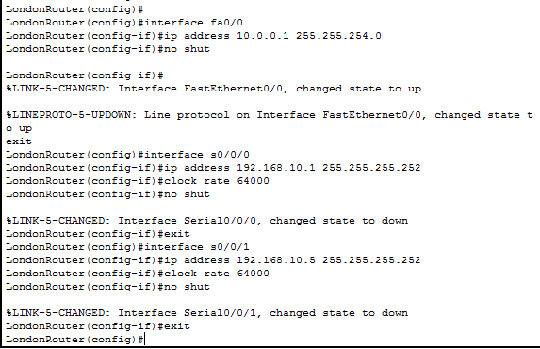

Device Name: BerlinRouter
Interface Name: Fast Ethernet 0/0
IP Address: 10.0.6.1
Subnet Mask: 255.255.255.192

Interface Name: Serial 0/0/0
IP Address: 192.168.10.9
Subnet Mask: 255.255.255.252

Interface Name: Serial 0/0/1
IP Address: 192.168.10.6
Subnet Mask: 255.255.255.252
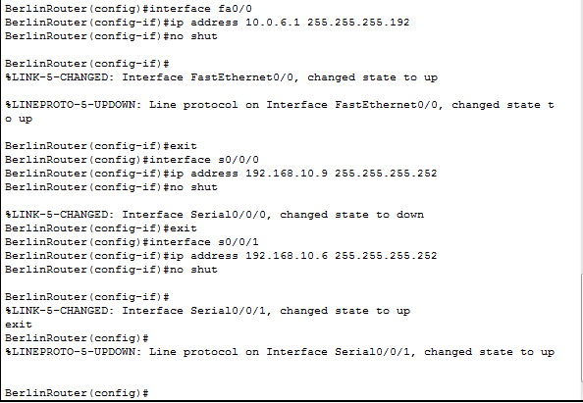

Device Name: SingaporeRouter
Interface Name: Fast Ethernet 0/0
IP Address: 10.0.4.1
Subnet Mask: 255.255.255.0

Interface Name: Serial 0/0/0
IP Address: 192.168.10.10
Subnet Mask: 255.255.255.252

Interface Name: Serial 0/0/1
IP Address: 192.168.10.13
Subnet Mask: 255.255.255.252
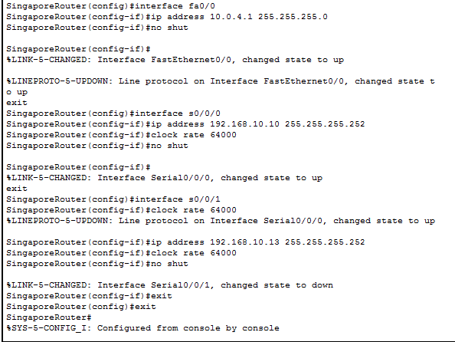

Device Name: SydneyRouter
Interface Name: Fast Ethernet 0/0
IP Address: 10.0.2.1
Subnet Mask: 255.255.254.0

Interface Name: Serial 0/0/0
IP Address: 192.168.10.17
Subnet Mask: 255.255.255.252

Interface Name: Serial 0/0/1
IP Address: 192.168.10.14
Subnet Mask: 255.255.255.252
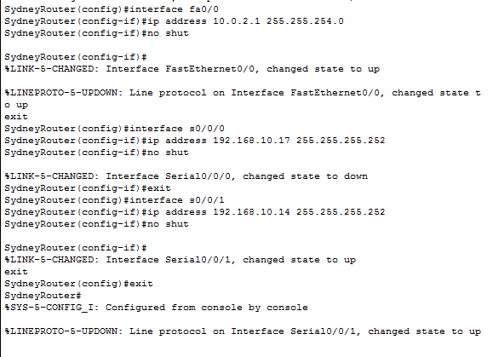

Device Name: BombayRouter
Interface Name: Fast Ethernet 0/0
IP Address: 10.0.6.65
Subnet Mask: 255.255.255.224

Interface Name: Serial 0/0/0
IP Address: 192.168.10.18
Subnet Mask: 255.255.255.252

Interface Name: Serial 0/0/1
IP Address: 192.168.10.21
Subnet Mask: 255.255.255.252
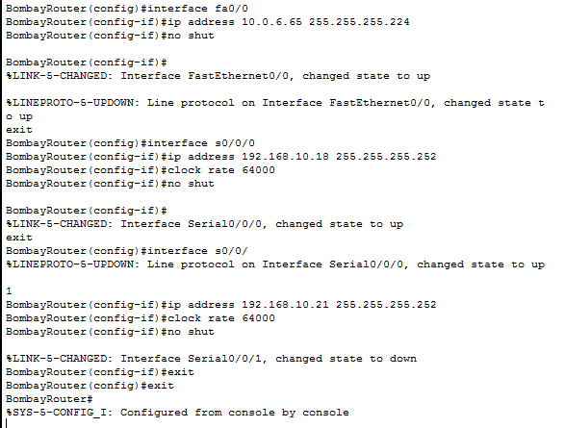

Device Name: TokyoRouter
Interface Name: Fast Ethernet 0/0
IP Address: 10.0.5.0
Subnet Mask: 255.255.255.128

Interface Name: Serial 0/0/0
IP Address: 192.168.10.25
Subnet Mask: 255.255.255.252

Interface Name: Serial 0/0/1
IP Address: 192.168.10.22
Subnet Mask: 255.255.255.252
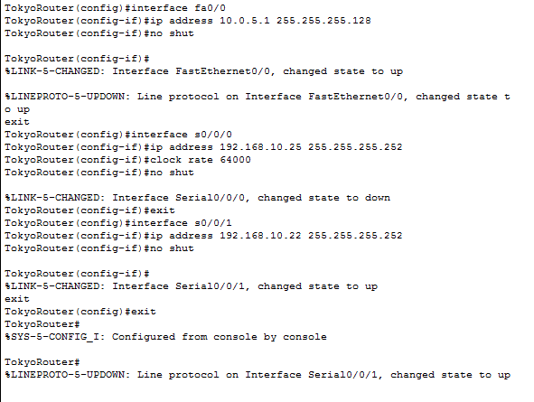

Device Name: SacramentoRouter
Interface Name: Fast Ethernet 0/0
IP Address: 10.0.5.129
Subnet Mask: 255.255.255.128

Interface Name: Serial 0/0/0
IP Address: 192.168.10.2
Subnet Mask: 255.255.255.252

Interface Name: Serial 0/0/1
IP Address: 192.168.10.26
Subnet Mask: 255.255.255.252
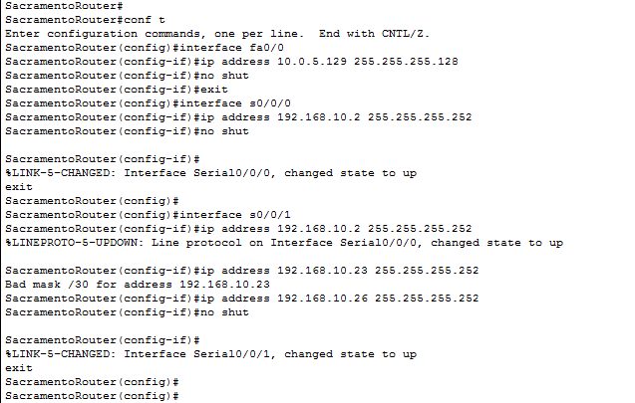

Basic Configuration
Setting Console Password
LondonRouter#conf t
LondonRouter(config)#line console 0
LondonRouter(config-line)#password cisco
LondonRouter(config-line)#login
LondonRouter(config-line)#exit

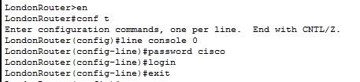
Setting Telnet Password
LondonRouter#conf t
LondonRouter(config)#line vty 0 4
LondonRouter(config-line)#password cisco
LondonRouter(config-line)#login
LondonRouter(config-line)#exit
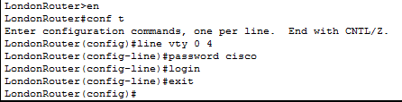

Setting Secret Password
LondonRouter(config)#enable secret class

DHCP Configuration
LondonRouter#conf t
LondonRouter(config)#ip dhcp pool DHCPLondon
LondonRouter(dhcp-config)#network 10.0.0.0 255.255.254.0
LondonRouter(dhcp-config)#default-router 10.0.0.1
LondonRouter(dhcp-config)#exit
LondonRouter(config)#ip dhcp excluded-address 10.0.0.1
LondonRouter(config)#
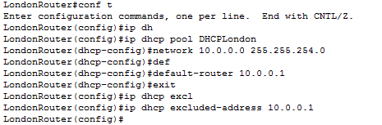
RIP Configuration

LondonRouter#conf t
LondonRouter(config)#router rip
LondonRouter(config-router)#version 2
LondonRouter(config-router)#network 10.0.0.0
LondonRouter(config-router)#network 192.168.10.0
LondonRouter(config-router)#network 192.168.10.4
LondonRouter(config-router)#no auto-summary
LondonRouter(config-router)#exit
LondonRouter(config)#
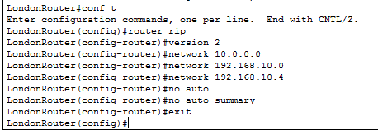

Show Routing Table
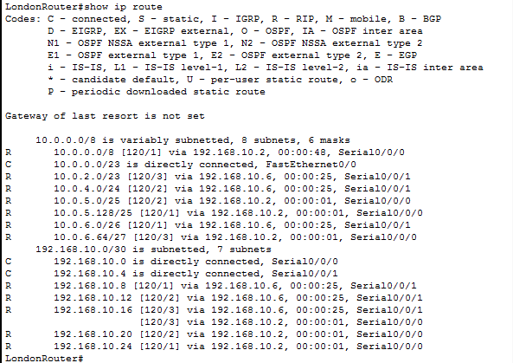

Show DHCP Configuration
From Sacramento,
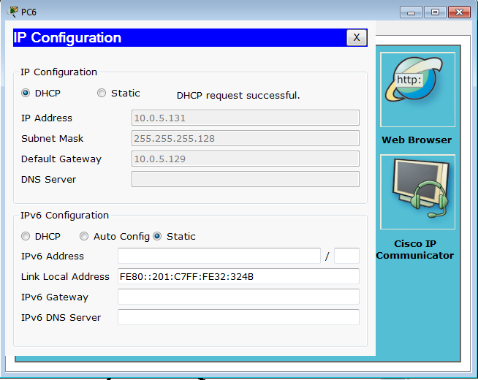

Testing
Ping from London PC to Tokyo PC

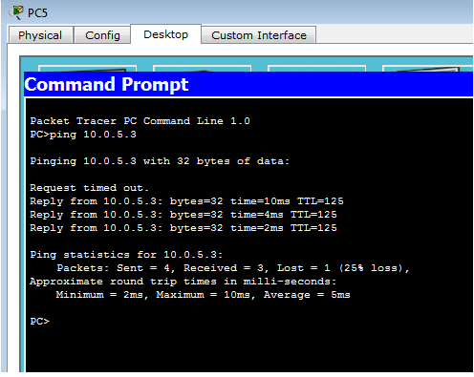

Ping from Sydney PC to Berlin PC
