Sales Planning and Operations

Introduction
The main objective of this report is to analyze the importance and the role played by the functions of sales planning and operations in the organization. The report also focuses on the various tools at the disposal of the organization which enable the concern to better focus its initiatives and use its resources.

Task 1

1.1 Explain how personal selling supports the promotion mix
Personal selling is the art of presenting the features of the product to a prospective buyer in a planned way in order to affect the sales. Personal selling includes techniques such as traditional selling and relationship selling. Personal selling is the form of selling where there is a direct interaction between the customer and the sales person who can be the sales executive, district manager, account executive, agent or others (Wallace and Stahl, 2008). Personal selling is an integral part of the promotional mix and the same can take the form of face to face communication, telephonic communication etc. It is through the sales force that an organization can understand the problems of the customers instantly. These are the people who represent the organization and act as a link between the customers and the company. For the purpose of selling the products of the organization a two strategy can be taken up by the concern in form of push and pull strategy. The push strategy is used to take the product to the customer thereby creating a demand for the same. A pull strategy is the opposite where the customer comes to product as he has been motivated to buy it through advertisement.
On the other hand, the procedures of personal selling play a crucial role in supporting various elements of the promotion mix. Many organisations are there that take advantage of the personal selling instruments in various ways.
a) Personal selling with advertisement: With the personal selling, the business organisations advertise their products via their selling executives. They recruited professional selling executives, so that, they are able to highlight the essential information in the advertisement. An advertisement is a physical and visual instrument through which an organisation can promote their products successfully (Sheldon, D. (2006).
b) Personal selling with sales promotion: Along with the personal selling with sales promotion brings many new customers to the organisation. Personal selling gives the organisation the chance to interact with the customers physically. As a result, they can evaluate their promotional plans to the customers face to face. This process assists the customers to have a better understanding of the product’s sales promotion.
c) Personal selling with direct marketing: direct marketing is the marketing policy where professional executives of the organisation inform about their products or policies to their customers via phone calls or messages. This procedure gives them the chance to assess information briefly to the consumers. This is a direct and affective way to interact.
d) Personal selling with public relation: Personal selling gives the sales executives of the organisation a direct chance to interact with the customers. This gives them an opportunity to build a strong relationship with them. This process gives organisation a chance to connect with the consumers.
e) Personal selling with the internet: Internet is the most powerful medium in the 21st century. This process helps the executives of the organisation to send email and offers to the consumers via internet and it is a most effective way to interact with the customers as most of the consumer prefers internet nowadays to get information about their products.

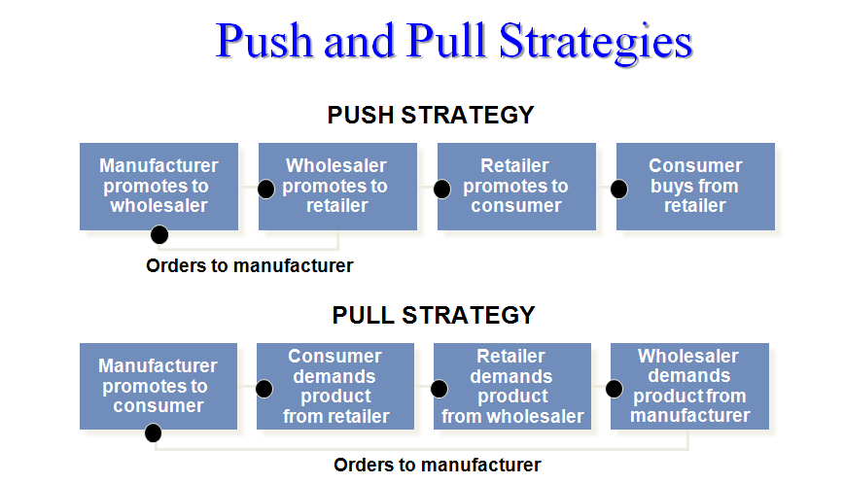
The objective of the organization sets the promotional mix of the organization which at times can also depend on the budget set by the concern which can be as a percentage of sales etc (Palmatier and Crum, 2003).

1.2 Compare buyer behaviour and the decision making process in different situations
It is not just the buyer who is responsible for making the decision but there are number of players who are involved in the same (Sheldon, 2006). There are influencers who directly or indirectly persuade the buyer, then there are gatekeepers, initiators and finally the buyers.
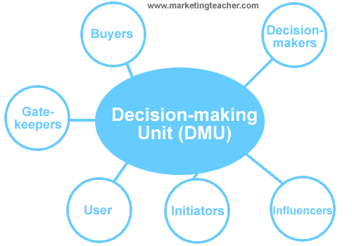
There are practically five stages involved in the decision making processes which have been illustrated below:
- In this stage the buyer is able to recognize the problem or is able to single out the need. This is the first stage or step of the process in which the buyer takes a decision in regards to the purchase of a product or a service.
- In the second stage, the buyer is concerned or involved in searching information on the product and searches the available sources for the same. This stage has a significant influence on the purchase of the product (Sheldon, 2006).
- In the third stage the buyers evaluates the various options he has at his disposal and moves closer to purchasing the product or the service after evaluating each of the alternative and drilling down to one product or service.
- In this phase the decision regarding the purchase of the product is made by the individual or the group of individuals.
- Even though the product has been purchased in the previous stage the buying process does not stop there as the buyer tends to evaluate the product after the purchase and if the product is not good enough the same is improved upon.
The influences on the consumer purchase behaviour are:
- Personal
- Psychological
- Social
Influences on organisational buyer behaviour
- Environmental
- Organisational
- Interpersonal
- Individual
Other influencing factors in buyer behaviour
- Purchase occasion
- Buying interests and motives
- Buyer moods
- Level of involvement
However, the behaviours of the consumers deal with the B2B and B2C market largely. In both of the marketing process, the buying procedures start with the consumers’ need of the product. For example, most of the customers prefer buying products through the business to customers marketing policy rather than the business-to-business marketing policy. As the business-to-business policies largely deals with the interaction between an organisation and the whole seller market. On the other hand, the business to consumer process is made in keeping the customers in mind. With the business to consumer policies customers reacts emotionally and mentally. The customer’s behaviour is instigated by the advertisement and marketing policies of the organisation. In B2B policies business are made through more than one or sometimes two suppliers (Richter, 2002). Thus, the business process is little bit complex. However, in business to customers policies the consumers get the chance to interact with their products. It increases the chance of selling the product. In B2B, marketing the whole seller offers products in cheap rate and the customers sometimes buy products attracted by that offer. These are some major factors in the behavioural pattern of the customers in business-to-business and business-to-customer policies.

1.3 Analyse the role of sales teams within the marketing strategy
The salesperson of an organization can range from the behind the counter employee to the top most employee of the concern. It has been mentioned before that the personal selling is considered to be more effective than advertisement and other similar techniques as it serves the customers directly and bridges the gap between the organization and the customers (Careers in meeting and events management, hospitality marketing, 2005). The same is useful in understanding the concerns of the customers and communicating the same to the organization. One of the key elements of personal selling is the management of the sales force of the concern in terms of compensation, recruitment design etc. The sales force can be designed or segregated on the basis of territory, product category, customer category and a mix of the three. The most important asset of the organization is its sales force as it the reason why the revenue is generated in the first place. The main objective of the organization is to manage the workforce of the concern in terms of the outside and inside sales force and tea selling. The sales force of the organization has to be monitored on a regular basis in order to ensure that the sales force is working efficiently and effectively. The sales force of the basis of the evaluation is also required to be motivated through incentive schemes and other methods such as sales quotas (Schwartz, 2006).

Task 3

3.1 Explain how sales strategies are developed in line with corporate objectives
The corporate objectives of the organization are set of statements, which provide a direction to the concern. The same allows the concern to align its activities with the aims and objectives of the organization. The conflicts and the confusions in regards to the objective of the concern can be resolved with the help of this statement. The same is also used to quantify the goals of the concern as a consequence the same becomes ore achievable (Seifert, 2003). After the corporate objectives of the organization are set the organization needs to conduct a market audit or analysis aimed at understanding the external factors influencing the operations of the organization. This audit enables the concern to understand which products to introduce and where to introduce the same. Based on this analysis the strategy of the organization is decided for instance if the organization should go personal selling or should it go for push strategy etc. After the external analysis has been successfully completed the organization should ensure that a SWOT analysis has been conducted to analyze the weaknesses and strengths it has. Based on this analysis the sales strategy of the organization is refined further.
If a company aimed to sell a particular, amount of products in a certain amount of time and it became successful then it somehow fulfilled the organisational objective largely (Lee, K. (2005). An organisation can only grow if it sales objective are fulfilled as it is one of the main components of the business. Organisations like star bucks or Wal-Mart, every year they set an organisational objective like to do a business of a certain amount or to meet the perfect amount of the profit percentage in a year. Thus to achieve it company needs to sale their products efficiently. These two factors are related to each other. The corporate objective and the sells objective is related with the communication process with the customers. The more an organisation can link them with the customers the more the customers will understand about their product and will show interest to buy it. These process ultimately resultant in fulfilling the organisational objective properly.

3.2 Explain the importance of recruitment and selection procedures

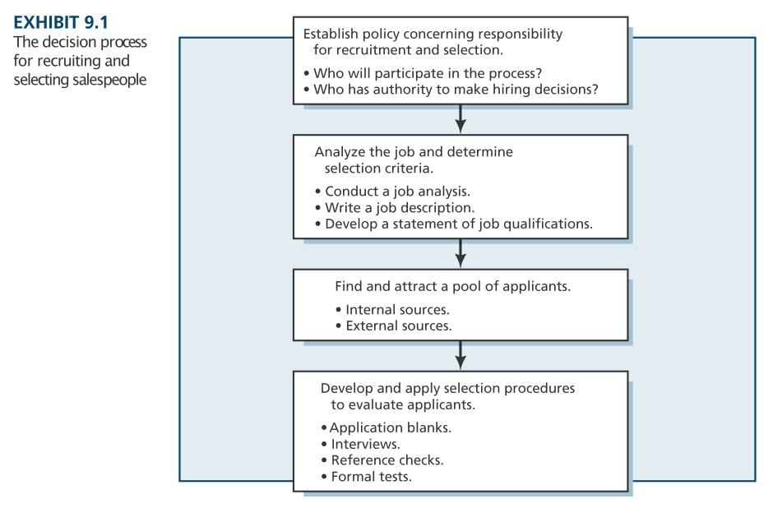
The sales force of the organization is chosen based on the type of product it is selling and the type of marketing strategy it has adopted or wishes to adopt in the future. Generally the sales force is chosen by the level one managers of the concern. Based on the requirement of the organization and the past experience the job role and the required qualification are set based on which the recruitment is made. The job descriptions are set of the aforementioned basis and other factors to minimize the failures associated with the person (Simpkins, 2004). The success of the organization is dependent upon the performance of the sales force which in turn in dependent upon recruitment process and hence it is for this reason the organization should recruit the sales staff carefully. In addition to external sourcing the organization should also focus on internal resources as the same is cost effective and more successful. Based on the requirement of the organization the recruitment is made through various avenues such as external agencies etc. It is based on this analysis that the steps in the interview process is decided upon such as the types of tests to be conducted the level of background checks etc. The sales force of the concern is very important and it is for this reason that the same needs to be selected on a careful note.

3.3 Evaluate the role of motivation, remuneration and training in sales management
For any organization be it involved in direct selling or not the motivation of employees and training is quintessential as the same goes a long way in maintaining the productivity level of the organization. It is for this reason that the staff needs to be motivated and trained appropriately so that the organization can get the required results through productivity (Lee, 2005). According the theory of Abraham Maslow and Herzberg the basic needs of the employees have to be satisfied which include motivation which is connected to job security, training, remuneration, appreciation and other factors. If these factors can be taken care of the staff would be motivated which in turn improves the productivity and reduces the rate of attrition of the concern which is also an important aspect as with a sales profile the attrition rate is quite high. Training allows the organization to reap and harvest the existing skills of the employees and develop newer set of skills which in turn allows them to move on to the next level.

3.4 Explain how sales management organise sales activity and control sales output
“Life is pretty much a selling job. Whether we succeed or fail is largely a matter of how well we motivate the human beings with whom we deal to buy us and what we have to offer.” Zig Ziglar,
The sales activity of the organization is synchronized and controlled by the management through various methods. The entire method of the organization can be categorized into the below mentioned activities:
Pre-Sales Activities: The executives and the other personnel have to be prepared for the sales call. The same involves taking into account the strategies followed by the competitors, the background of the customer etc. The services and the product offered by the organization is then compared with the services and the products offered by the organization (McLeod, 2010).
Sales Activities: This is the real execution of the plans that have been prepared in the previous stage. In this stage the sales is concluded by the organization through relationship building etc.
Post Sales Activity: This stage is concerned with relationship building with the customers after the conclusion of sales.
The sale management system can be more affective implying various methods of business. The sales management system is used to get an affective result in selling a product. The push and pull strategy makes the marketing procedure easier. A widely used marketing strategy helps a business to maintain sustainability in the market. The demand of the product is defined as “pull”. The consumers generally demand the products that they want and taking this advantage the seller supplies the product to the customers, this process is defines as “push”. This strategy encourages the sellers to produce the products that the customers want. It is a direct selling process, that means the seller meet the customers face to face. It also gives the customer a chance to negotiate the price with the seller. The supply chains gain a lot form this strategy as judging the demand the seller can send their products to the market. The process of taking orders from the customers also falls in this list. While taking orders from the customers the seller needs to contact the customers or the retailer first about the quantity of the product and according to the need the seller can supply the products to them.
Another way to managing the product is to prepare a selling meeting with the employees of the organisation. Preparing sales meeting assists the employees to understand the overall strategy of the organisation. In the meeting, the institution also needs to look about whether the institution is meeting the qualifying sales lead or not.

3.5 Explain the use of databases in effective sales management
For any organization to be successful, the concern needs to analyze the pattern in regards to the sales. It is for this reason the organization needs to maintain a database of the customers to understand the sales pattern. In order to satisfy its information needs the organizations can maintain the customer database through a number of software such as Oracle, Microsoft Access etc. The software enables the organization to improve the availability of the data and reduce the quantum of redundancy (Bebchuk, 1994). The same is reduced as the organization does not have to maintain storage devices etc. The employ of such software enables the concern to improve the security connected with the data storage and its accuracy. Based on the trends analyzed the organization can structure its strategies to suit the market trends and demographics. With the assistance of the software the organization can prepare and execute the membership and subscription lists. The software is also helpful in maintenance of the accounts and the data can later be used for scientific research and maintenance of customer information.

Task 4

4.1 Develop a sales plan for a product or service
Sales Channel: The organization has been planning to launch its new line of tablet PC’s. The new line of tablet PC’s would be sold to various segments of customers through various marketing channels or funnels at the disposals of the concern. The retail chain would be employed by the concern to serve or distribute the products to the consumer segment whereas the organization segment would be served directly.
Target Margin: The target crowd would be the people who value durability and class as opposed to people who only use PC’s for their basic needs. Hence based on this target the features and the appearance of the product would be set apart from the similar products (Schwenzer and Fountoulakis, 2007).
Marketing Mix: Various channels of marketing would be used by the organization to market the product primarily aimed at attracting the customers belonging to the upper sects of the society. The product would be advertised through online media and television advertisements in addition to the conventional modes of marketing such as newspapers etc.
Promotional Mix: For the purpose of promoting the product the organization would make use of various modes of advertisements such online media, print media and other sources as has been previously mentioned.
Sales Forecast: It is expected that the organization would be able to sell 1000 units of the product in the first quarter and approximately 5000 units by the end of the year. The sales is expected to double in the 2nd and 3rd year after which there should be a 10% growth till the 5th year.
Along with the previous discussed strategies some additional sells plan is also necessary, for example the organisation at first needs to analyse the marketing situation. Marketing situation is just like a business plan where the institution needs to evaluate the demand of a particular product then according to the demand they need to divide the their marketing region. There might be variation in the demand ratio in many places, thus according to the demand and popularity of the product the organisation needs to act. Even this is not enough, the company needs to set a sales target and it will be better if they divide the yearly sales target into monthly targets. Without a sells target an organisation is aimless. Thus, the monthly target helps them to achieve the goal as fast as possible. After setting, the target the organisation needs to build a sales strategy. Sales strategy provides a procedure to the organisation following which the organisation can do a business professionally. Sales strategy means to understand the consumer’s taste and to understand the market as well. A genuine and perfect sales strategy is very necessary to develop a successful business. To maintain a sales strategy the factors of the economic condition of a country and the elements of globalisation is also necessary. The factors of the primary and the secondary sales strategy are also necessary. As the primary sales strategy, initiate the communication between the seller and the buyer directly. On the other hand, many factors of the secondary sales strategy are linked with the primary sales strategy. Thus, both are crucial in developing a business. Among all these strategies and planning, making a budget is necessary. A budget helps the organisation to spend money correctly in every sector of the business (Wallace and Stahl, 2008). With the help of the budget an organisation does not over spend in any of their sectors. A proper maintenance of the budget is necessary along with the budget. Thus, the organisation needs to concentrate on maintain the budget properly. Besides an organisation needs to maintain its sales plan through push and pull strategies.

4.2 Investigate opportunities for selling internationally
The product has a great scope to be marketed and sold internationally as the same is a product which has gained relevance in the recent times and hence there is a huge scope for the sales of this product. The organization would have to target the areas with prospectively a slightly higher rate of success such as other parts of Europe and Asia. These are the areas where the organization is expected to reap more benefits (Schwenzer and Fountoulakis, 2007). After the same has been achieved the organization can then target various other regions such as Africa and South America. The product should be released in various version to attract various sects of customers in these regions since pc’s can easily be customized based on the features. In these countries as well the target would be the customers from the upper sects of the society but at the same time some relevance would also be given to the middle class people. The products in these regions would be sold through established retail chains such as supermarkets and other renowned retail stores. Once the same has been successfully achieved the organization would attempt a more direct penetration in these markets. Once the same has been achieved the organization would standardize the product and consequently only one variant of the product would be sold across the regions.
Globalisation plays a huge role in the modern business procedure. It gives a business an opportunity to grow faster in the international market. If an organisation is linked with the process of globalisation then it needs to go through various factors, as doing business internationally is not an easy task (Bebchuk, 1994). The organisation needs to keep certain things in mind. Taking the clothing brand Zara as an example it can be evaluated that the organisation is doing business all over the world. However, before going internationally the organisation initially needed to take many information of the countries where they going to do the business. Like, evaluating the consumer’s taste and style in that country. Zara is a clothing brand. Thus, they need to take care of the fashion sense all over the world. Some fashions might be popular in the United Kingdom; however, the particular fashion sense might not go with the style of UAE or India. Besides there might be some certain local competition that can bother their business, for these reason the organisation needs to think about taking franchise. Franchise system gives the international organisation an opportunity to collaborate with the local business. It helps them to understand the local demand and taste of the market. The supply chain management helps the organisation to supply all the raw materials and other products in tine so that they can meet the demand. The economic position of the particular country need to be evaluated. The country might be a first world country or a developing country; the economic factors are different in both the case. Thus, keeping that thing in mind the organisation needs to assess its opportunity in the international market. With all these factors, the organisation needs to take care of their transporting cost in the business. If a particular, company is doing business in UAE and they are importing the raw materials from the international market then the cost of the business might become excessive. Thus, the organisation needs to find a local raw materials manufacturer for the profit.

4.3 Investigate opportunities for using exhibitions or trade fairs
Now a days a lot of trade exhibitions and trade fairs are organized to encourage the organizations to display the upcoming and new products. These fairs and exhibitions provide a solid platform to the organizations to showcase their products. The trade fairs have fee associated with them. Even though the organization has to pay a fee to book a spot the same is relatively inexpensive as compared to the other conventional modes of marketing. This allows the organization to market their product and collect the feedback of the customers first hand. This feedback can allow the organization to make adjustments and modifications to the product before the actual release is made and hence the product released is more realistic in terms of the expectations of the customers and has a better prospect for sales. Exhibitions increase the impulse in customers to buy the products (Tracy, n.d.). Such exhibitions can be of two types the first being for the customers and the other being for the industrial consumers. Exhibition has the same impact as free sample and at the same allows the organization to collect the valuable feedback of the customers and implement the same accordingly. In terms of technological products such as computers trade fairs and exhibitions are very common and have proven to be very good launching pads.
Conclusion
The report above has indicated the importance of the sales planning and forecasting and has shown how the same is helpful to the needs of the organization. The organization needs to plan its activities keeping in view its products and strategies in order to reap the best out of the available resources.

