Introduction
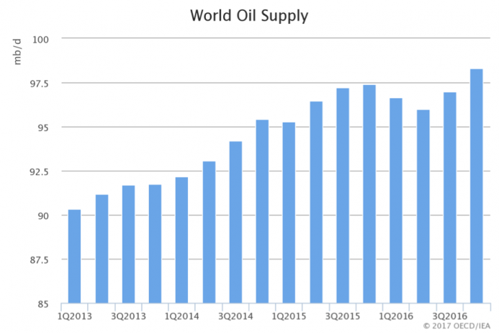
Figure: World Crude Oil Supply
Source: (Wirl, 2017)
In the advent of the decision that has been taken by the OPEC countries regarding the considerable production cut, the strategic importance of crude oil in the premises of global economy has been established again. Furthermore, this strategic importance of crude oil consolidates the notion of monopoly that OPEC countries flagrantly exercises having the possession of 78 percent of global conventional petroleum reserves. However, some of the comprising countries (such as Iran) appear unfazed regarding this cardinal decision about the crude oil production and still uses their petro-dictatorship to obtain global political influence (Baardsen, 2017). This dimension of indispensability imposed on petroleum is nothing but a product of monopolistic market structure framed upon the artificial hindrances posed by the petro-dictators in order to employ the market structure to pursue their didactic purposes (such as driving regional unrest). In this regard, the current study suite is supposed to evaluate the market structure of this global oil trade against the rudimentary questions of this oil cartel of OPEC.

Market Structures
In empirical terms, the market of oil trade is archly monopolistic as the industry of transportation is still dependant on petroleum being devoid of equivalent substitutes. This dependence on oil simultaneously justifies the complacence that inherently resists the OPEC countries to promote non-conventional sources of fuel. In fact, as per some reliable statistics, the notion of OPEC domination regarding the trades with oil is a potential farce since the oil production rate has been stained with a prolonged stagnation since, in the same course of time, the non-OPEC crude oil production units have doubled their rate of production (Markus, 2016). As per some recent statistics, US, being one of the major exponents of petro-dictatorship have increased their amount of oil export almost by twice from the amount of oil they export from OPEC immediately after the Arab oil embargo. This event is pivotal in the arena of global oil trade since it has caused provincial conflicts and increase in the poverty index while exhibiting a massive transfer of wealth from the poorest countries to the oil-exporting despotic kingdoms.
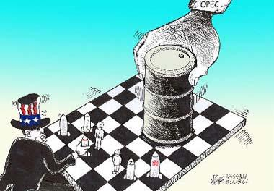
Figure: The game of Monopoly
Source: (Wright-Maley, 2016)
Difference between Monopoly and Oligopoly
In monopoly, as per the empirical definition, the entire economic is dominated by an individual trader whereas in Oligopoly intends to define a market place with a presence of diverse traders as tiny number of large firms are supposed to dominate the entire economic market.
In monopoly, as the seller is the sole dictator of the terms of trade, they can charge higher prices. This tendency has been patronized by the flagrant absence of equivalent substitutes. On the other, oligopolistic economic markets are vulnerable to impose moderate or fair prices, as there is an active presence of competitors (Markus, 2016).
Monopolistic economic market is chiefly a capital-intensive entity and supposed to exhibit a considerable hostility in terms of entering the prevalent market. These hindrances are typical to be created chiefly framed upon technological expertise, governmental legislation, copyrights and distribution overheads. It is comparatively less in the oligopolistic ambience due to disordered scale of economies.

Is Oil market a Monopoly?
The global oil market evidently exhibits the characteristics of a monopolistic economic market since the terms are prone to be dictated by the OPEC countries and the rest of the oil-importing countries are supposed to comply with their prescribed protocols. Furthermore, the OPEC countries act as the prior regulator of global economic index of oil trade. Apart from that, the fact that consolidates such dictatorship of OPEC countries is that they enjoy the possession of almost 78 percent of the conventional crude oil reserve across the globe (Wright-Maley, 2016). This petro-dictatorship of the OPEC countries enable them to pose artificial hindrances and economic constraints on the global trade of crude oil that is nothing but a product of the complacence that they require to pursue their monopolistic snobbery. There are ample alternatives to topple this monopolistic façade of oil trade since, the transportation industry, might use electricity as a mean of fuel that might subdue this indispensability of crude oil. Furthermore, it can be stated that it is an urgent necessity to replace crude oils as the only transportation fuel since this encourages the petro-dictators to retain this monopolistic market structure.

Breaking Oil’s Monopoly and OPEC’s Cartel:
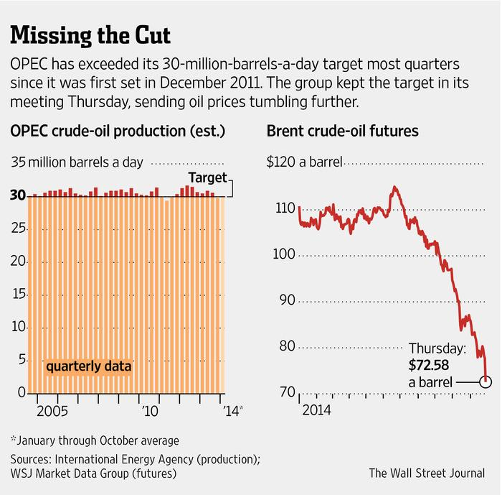
Figure: Overview of Vienna Summit of OPEC countries
Source: (Wirl, 2017)
If it is an axiom (that the petro-dictators enforce to endorse) that the indispensability of crude oil endow the entity with a coinage of strategic commodity, it is imperative to break the Oil’s monopoly which appear to be nested in OPECs cartel as a counter-strategy. The transportation industry has been the prime province that requires to incorporate substitutes of crude oil in order to strike the artificially imposed hindrances from OPEC in terms of strategic retreat. For instance, the underlying market has enjoyed the sheer availability of hydrofractured or fracked natural gas that might serve the purpose in the short run. Moreover, the major countries with natural gas reserves (such as Russia, Iran) might establish a strategic nexus that might facilitate the breaking of OPECs oil cartel (Baardsen, 2017). An urgent strategic reform is required since the global trade on oils is gradually getting unipolar and the emerging grievances became impotent due to the absence of proper arena of dictating. Moreover, the obtaining of political influence is also a strategic requisite since it might contribute the causes of the nexus.

Reasons of enjoying command:
As per the current statistics prevalent in the current discipline, OPEC countries are supposed to wield the underlying oil market mainly due to the possession of almost 78 percent of the natural reserves of crude oil. Moreover, they happens to be global index of the oil export economy since the major decisions regarding the production cut are need to be granted by them in order to obtain acceptance across the globe (Wirl, 2017). The high export prices that are supposed to patronize the autocratic kingdoms of several countries appear to favor the exporting countries to retain the monopolistic nature of the underlying market. Moreover, several countries ( and most of them are non-OPEC) have been able to produce more crude oil as compared to the OPEC-countries appear complacent regarding their individual status and does not exhibit any interest to participate in any global forum in order to counter the unipolar approach of oil export.

The role of Ethanol:
As most of the countries decided to avail the liberal way of combating this monopolistic market of crude oil trade, they seek an equivalent substitute of crude oil to serve the transportation industrial requisites. In this regard, ethanol, that is nothing but grain alcohol appears to be the exponent that is even cheaper than gasoline itself. In this regard, it appear imperative to admit here that the controversy that has emerged within a recent course of time regarding it being a exclusive food-fuel and gross deviating the considerations regarding the blenders credit tariff. In short, if people are not willing to drive on ethanol, they are supposed to contribute in the food production but in this trajectory, it is unable to pose the remedy of the global oil trade crisis (Wright-Maley, 2016). In this regard, Brazil has been able to produce ethanol from sugar cane as a worthy competitor. In this regard, those who are willing to include ethanol as a circumspect substitute of crude oil, can be recommended to incorporate a little dimension of methanol in it since it might transform it in a flex-fuel that is something the market industry is craving for.

Market structures affecting supply outcomes
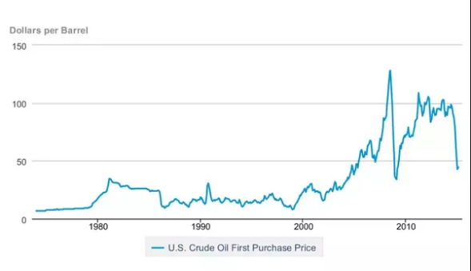
Figure: Production Cut
Source: (Wirl, 2017)
A monopolistic market structure is potent enough to influence the supply incomes since the notion of autocracy associated with monopoly enable the dictators to impose whatever price they intends to on a particular product. In the current context, for instance, the unanimous decision of production cut affiliated by the OPEC countries is chiefly satisfy their intention introduce a hike in the prevalent prices. As it was flagrant regarding the current trends that a massive amount wealth has been transferred from the poorer region towards the wealthy ones, It consolidates the fact the despotic Kingdom of US is supposed to charge twice upon the rate during Arab embargo.

Relative Comparison
In terms of UAE, another country might be allowed to enter this paradigm of discussion where the only eligibility is that the country needs to be a prospective OPEC member. In this regard, Iran could be opted since it is the only country in OPEC that appear unfazed regarding the aftermath of the decision of production cut in order to introduce a significant hike in the prevalent prices of oil (Markus, 2016). Such attitude of Iran can be justified regarding the fact that being the product a theocratic hierarchy, they enjoys an advantage to obtain political influence while being a cardinal exponent of OPEC, the regulator of global financial index of oil trade.

Conclusion
The OPEC countries appear to be the hindrance in the trajectory of practicing liberal economy, as they are prone to use the façade of monopolistic market as a tool to pursue their didactic interest. Apart from gradual hike in the global prices of oil, their despotic global demeanor happens to cause regional conflicts and increase in poverty. In this regard, the transportation industry which is supposed to be the component that indulges the dimension of indispensability of crude oil can be recommended to seek a equivalent substitute of petroleum (such as ethanol or Plug in Hybrids) in order to combat the autocratic demeanor of the OPEC cartel.

