Introduction
The aim of this report is to provide the projects that suit the company’s following assumptions. They are the CAPEX of the approved project cannot be higher than $10 billion and every year, a total less than $4 billion should be spent on the projects. With the following as an aim, the first part of the study is carried out. The second part of the study, on the other hand, is quite different as some restrictions are imposed to determine the best projects for consideration based on the probability. The third part of this report will focus on identifying the suitable projects, therefore, the explanation regarding the approach taken in the report.
Part-A
The first step is about measuring the suitability of the projects when there is no uncertainty to consider. The best projects are selected based on the excel calculations such as NPV.
Best Sets of Cases to consider
The best cases to consider will be decided based on the NPV values measured. In order to determine that, the NPV as % of total CAPEX ratio is considered to select the projects with higher NPV. If all 12 projects are considered, the best possible options can be these. The Projects selected are 4, 5, 7, 10 and 11. 4 and 5 belong to the Functional Area 1 and the projects 7 belong to the Functional Area 2. The projects 11 and 10 belong to the Functional Area 3. The following will be the CAPEX of the company and Functional Areas of the project.

Figure 1 Part-A Analysis

The Projects has the following values as NPV. The highest NPV is for the project 7 with 22.8% of total CAPEX.

Table 1 Part-A CAPEX NPV
Project Code | NPV as % of total CAPEX | NPV
4 | 20.00% | 310.00
5 | 15.70% | 165.00
7 | 22.80% | 410.00
10 | 14.30% | 100.00
11 | 17.30% | 130.00

Part-B
This part started with the 15% below and 30% above the most likely Capex limit for the project is considered. The minimum and maximum value allocated for the NPV, on the other hand, is 15% and 20%. The beta-PERT model is identified as a suitable model and it is used for the analysis. The probability distribution of the NPV is simulated with the help of simulation tools. The following will act as the histogram for the analysis. The projects selected from the question 1 are 4, 5, 7, 10 and 11. And the following are the NPV identified.
Table 2 Part-B NPV
Project Code | NPV
4 | 310.00
5 | 165.00
7 | 410.00
10 | 100.00
11 | 130.00
Total | 1115.00

The minimum value of the NPV here is for the project 10 where the NPV is 100. The Maximum NPV is for the case is 410 million. The total worth of the projects undertaken is closer to 1.15 billion.
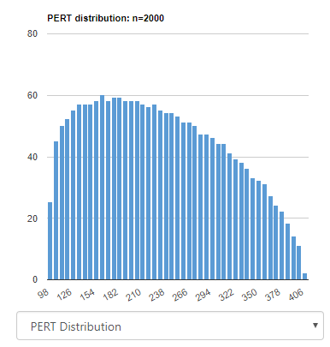
Figure 4 Histogram
The Pert Distribution indicates that the data here for the NPV is skewed positively. The simulation considered is based on a total of 2000 results. Based on it, the CAPEX and the NPV are selected to carry out the further research.

Part-3
Based on the analysis, these are the projects can be considered for the selection.
Table 3 Projects selected
 | Projects Selected
FA1 | 2,4 & 5
FA2 | 7
FA3 | 10 & 11
The Projects selected are 2, 4, 5, 7, 10 and 11. The projects 2, 4 and 5 belong to the Functional Area 1 and the projects 7 belong to the Functional Area 2. The projects 11 and 10 belong to the Functional Area 3. The following will be the CAPEX of the company and Functional Areas of the project.
Table 4 NPV as % of CAPEX
Project Code | NPV as % of CAPEX
2 | 16.36%
4 | 20.00%
5 | 15.70%
7 | 22.80%
10 | 14.30%
11 | 17.30%
The projects 2, 4 and 5 belong to the Functional Area 1 and the projects 7 belong to the Functional Area 2. The projects 11 and 10 belong to the Functional Area 3. Therefore, one project from each and every Functional Area is considered for the study.
Table 5 Total NPV and CAPEX
Project Code | NPV as % of total CAPEX | NPV | CAPEX
2 | 16.30% | 53.5 | 326.7
4 | 20.00% | 310.00 | 1395.00
5 | 15.70% | 165.00 | 945.00
7 | 22.80% | 410.00 | 1620
10 | 14.30% | 100.00 | 630.00
11 | 17.30% | 130.00 | 675.00
Total |  | 1115.00 | 5591.7

The NPV is highest for the Project is highest for the project 7 and project 4 is the second highest on the list. The rest of the projects are selected because they meet the requirements issued by the board. The table below will exhibit the total spending of the company and a breakdown of how much they spent on each project. The total worth of the CAPEX after the end of all projects would be 5.59 billion and the NPV would be 1.15 billion.

Table 6 Breakdown
 | Year 1 | Year 2 | Year 3
Company | 2038.5 | 1889.1 | 1664.1
FA1 | 958.5 | 899 | 999
FA2 | 675 | 675 | 270
FA3 | 405 | 405 | 495

The Part-C chart will exhibit the table above in a chart format.

Figure 5 Part-C

