Tenses
Introduction
Tense is the most significant section of Grammar. In order to write grammatically correct sentences it is important to have in depth knowledge of tenses that are used in English grammar. Tense is the primary element that indicates the time in which a particular incident happened. This report attempts to shed light on three different tenses and highlights different use of the tenses in accordance with its application. By using several examples, understanding of tenses has been displayed.
Definition
English tenses are primarily considered as the form that a verb takes in order to explain the time of a particular action.
Example: I ate fish. (Past tense)
I eat fish. (Present tense)
I shall/will eat fish. (Future tense)
In the paradigm of Grammar, tenses refer to the state of verb or the time of action. The examples focuses on the change of verb in defining three courses of action. Every verb is present with its three forms that are present form, past form and past participle form. However, in order to suggest a possible action of future an appropriate auxiliary verb is used in accordance with the subject of the sentence. In this case ‘will’ or ‘shall’ has been used.

Classification

Past tense
Past tense is used to indicate the events that already occurred.
Use of verbs: For regular verbs the past tense is formed through adding ‘–ed’ at the end of the verb in regular cases. There are exceptions to the rule as other suffixes are also attached including ‘-en’ and sometimes the verb remains unchanged.
Example: To listen (present)
Listened (past)
Read (present)
Read (past)
Regular verbs with containing short vowel sounds require only adding an extra consonant to the end of the infinitive before the addition of –ed. For instance drag>dragged and brag>bragged.

A verb that has a silent ‘e’ at the end only requires a ‘-d’ in order to create the past form. For instance require>required
There is no specific rules for the irregular verbs. The irregular verbs take different forms in order to create the past form.
Example: Eat>Ate
Bring> brought
Teach>taught
Buy> bought
Present tense
For describing the actions that are taking place in the present, present tense is used.
Examples: In order to express a fact, present tense is used.
He works in a MNC.
It does not imply that at this very moment, the subject is working but it represents a fact. In application of present tense it is important to remember that the present tense takes in account the infinitive base for all the conjugation. Example
First person singular and plural | Second person singular/plural | Third person singular | Third person plural
I hear. ( Singular)  We hear. (Plural) | You hear. | He hears.  She hears. | They hear.

This rule has an exception as well. This rule is applied to the verb forms except for the third person singular number. In a sentence where the third person singular number is the subject, there an ‘-s’ is added to the singular third person in order to establish the present tense.

Future tense
Future tense is used for the implied actions that are yet to occur.
The future simple tense expresses actions that have not taken place yet but going to occur in near future
Formation
Future tense is formed in two ways.
Rule 1: As per the first rule an auxiliary or modal verb is added between the subject and the infinitive base of the verb.
Example: I will go to the market tomorrow.
Rule 2: This rule indicates adding the word ‘going’ followed by the infinitive ‘to’ and then adding the infinitive of the verb form.
Example: I am going to tell the teacher.
We are going to sleep tonight.
It is important to understand the major types of tenses in English in order to apply them accordingly.
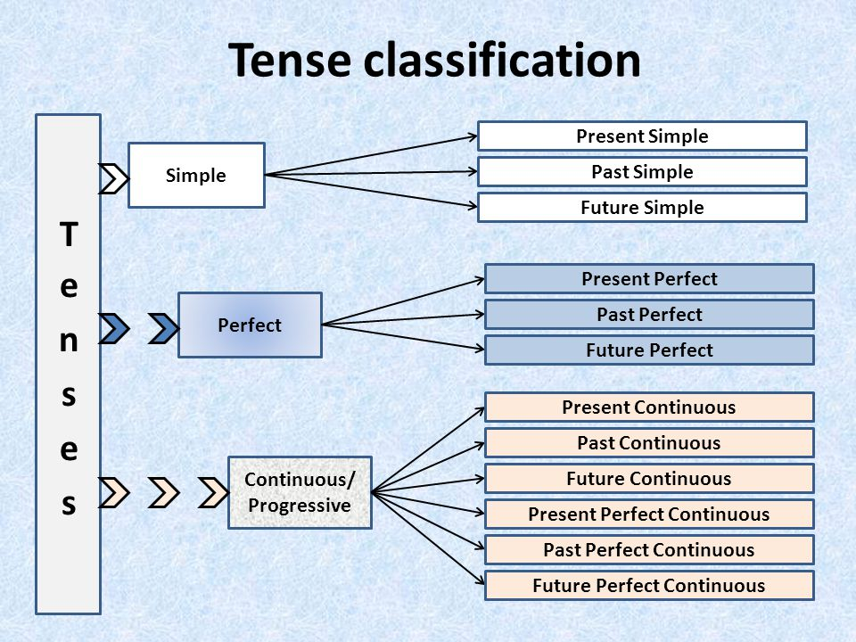

Past tenses
- Simple past
Form: Subject+ past form of the verb

Simple past is primarily used to discuss the actions that occurred at a specific time in the past. The actions can be short or long. This form is also used in describing the events that happened one after another.
Use
1. Events in the past that are finished now
2. Situation in the past
3. A series of actions in the past
Examples:
Use 1: John went to London last week.
I ate my dinner last night.
Use 2: I lived in Paris for 5 years.
Eva was in London for ten years.
Use 3: She entered the room, sat on the chair and talked to her friends.
Forming a sentence in the simple past is easy. However, the ease of forming assertive sentences is not found in the questions and the negative sentences.
- Past continuous
Form: Subject+ was/were + continuous form of the verb
Past continuous is usually used to describe the activities that lasted for some time in the past.
Use
1. Duration in the past
2. Interrupted actions in progress
3. Actions in progress at the same time in past
4. Irritation
5. Polite question
Examples
Use 1: Lily was dancing in the evening yesterday.
Use 2: I was on the phone when Harry came.
Use 3: I was reading a book and my mother was cooking.
Use 4: I was thinking that you can help me with my assignment.
Use 5: She was always coming late to school.

- Past perfect
Form: Subject+ Had+ past participle form of the verb
The past perfect tense is generally used to emphasize on the fact that a particular action in the past finished before starting of another action. This tense is also used in the reported speech and third conditional sentences.
Use
1. Completed action before another action of past
2. Third conditional sentences
3. Reported speech
4. Dissatisfaction with the past
Examples
Use 1: I finished the book before I went sleeping.
Use 2: If we started off earlier we would not have missed the train.
Use 3: She told me that she had already read the book.
Use 4: I wish I had not missed the beginning of the movie.
- Past perfect continuous
Subject+ had+ been+ past participle form of the verb
The past perfect continuous tense is used to describe the actions or the situations that were in progress before some other action or other situation.
Use
1. Duration of a past action up to a certain point in the past
2. Showing a cause of an action or a situation
3. Third conditional sentences
4. Reported speech
Examples
Use 1: The girls had been talking for almost an hour when I arrived.
Use 2: The road was wet as it had been raining.
Use 3: If the rain had stopped we would have been gone for playing.
Use 4: She said that she knew Nancy had been lying to her.

Present tenses
- Simple present
Form: Subject + verb
- Present continuous
Form: Subject+ is/am/are+ verb+ing
- Present perfect
Form: Subject + has/have+ past participle form of the verb
- Present perfect continuous
Form: Subject + has/have+been+ past participle form of the verb

Future tenses
- Simple future
Form: subject+ shall/will+ verb
- Future continuous
Form: subject+ shall/will+be+ continuous form of the verb
- Future perfect
Form: Subject+will have+ past participle form of the verb
- Future perfect continuous
Form: Subject+ will have been+ past participle form of the verb
Mostly simple future and future continuous tenses are used. Other two forms of the future tense are not used.
Conclusion
It is important to have adequate knowledge on tenses in order to form correct sentences. There are several exceptions to the discussed rules. Tenses can be classified as tense of happening, possibility, tense of impossibility and tense of expectation.

