Australian institute
of
music

Part-1: Entity-relationship data model

ER model is a graphical representation of entities and their relationship to each other, typically used in computing in regard to the organization of data within database. The meaning is described in terms of a conceptual or ER schema. ER schemas are comparable class diagrams in UML

List of entities

Entity: An object in the world that can be distinguished from other objects
Entity set: A set of similar entities
Here the following entities are:
- staff
- staff_course
- course
- instrument
- student
- student_course
- invoice

List of attributes
The basic unit of information about any entity occurrence. Here describe the list of attributes i.e;
- staff: staff_id, staff_name, staff_family_name, staff_dob, staff_phone, staff_add, staff_degree
- staff_course: staff_id, course_id
- course: course_id, course_name, cost, time
- instrument: instrument_id, instrument_name, course_id, stock_qty, manufature_name
- student: s_id, s_name, s_add, s_dob, s_phone, s_family_name, s_email
- student_course: s_id, course_id, datetime, course_duration, staff_id, payment, date_paid
- invoice: invoice_no, s_id, amount, date

Business Rules:
Business rules are the constraints that you wish to impose protect the database from becoming incomplete, inaccurate, or inconsistent. Although you may not be able to implement some business rules within the DBMS. It is concerned only with high-level design that is, specifying what business rules are required irrespective of how this might be achieved. Having identified the business rules, you will have a logical data model that is a complete and accurate representation of the organization to be supported by the database.
We consider the following types of business rules i.e, required data, column domain constraints, entity integrity, multiplicity, referential integrity, other business rules.
Here the business rule defined by the database i.e
- The minimum course time to teach is 30 minutes.
- The Maximum Course time to teach is 1 hr.
- Invoice will generate only after course is finished for the student.
- Invoice will be generated only for previous month completed course.

Assumptions:
- Student(s) cannot enrol is same course again if the last payment is due.

Part-II Relational database implementation

Normalization: Normalization is a formal process for design which attributes should be grouped together in a relation. Normalization can be a conventional method regarding design which attributes needs to be grouped together in a relation. Just before proceeding with all the physical design we'd like a strategy to confirm the particular logical design to this point. Normalization is a tool to be able to confirm & enhance the logical design. It requires to fulfil a few constrain.
There are several normal forms defined,
First Normal Form (1NF)
Second Normal Form (2NF)
Third Normal Form (3NF)
Boyce codd normal form (BCNF)
Fourth Normal Form (4NF)
Fifth Normal Form (5NF)

First Normal Form:
First Normal Form eliminates repeating groups by putting each into a separate table and connecting them with a one-to-many relationship.
Two rules follow this definition:
- Each table has a primary Key made of one or several fields and uniquely identifying each record
- Each field is atomic, it does not contain more than one value.

Second Normal Form:
Second Normal Form eliminates functional dependencies on a partial key by putting the fields in a separate table from those that are dependent on the whole key.

Third Normal Form:
Third Normal Form eliminates functional dependencies on non-key fields by putting them in a separate table. At this stage, all non-key fields are dependent on the key, the whole key and nothing but the key.

Here the table are fully normalised i.e,
- staff (staff_id, staff_name, staff_family_name, staff_dob, staff_phone, staff_add, staff_degree)
It’s Primary Key: staff_id
- staff_course (staff_id, course_id)
Foreign Key (staff_id) References staff(staff_id), Foreign Key (course_id) References course(course_id)
- course(course_id, course_name, cost, time)
It’s Primary Key: course_id
- Instrument (instrument_id, instrument_name, course_id, stock_qty, manufature_name It’s Primary Key: instrument_id)
Foreign Key (course_id) References course(course_id)
- Student ( s_id, s_name, s_add, s_dob, s_phone, s_family_name, s_email)
It’s Primary Key: s_id
- student_course: s_id, course_id, datetime, course_duration, staff_id, payment, date_paid
Foreign Key (course_id) References course(course_id), Foreign Key (s_id) References student(s_id)
- invoice (invoice_no, s_id, amount, date)
It’s Primary Key: invoice_no, Foreign Key (s_id) References student(s_id)

Functional Dependencies
A functional dependency (FD) is a constraint between two sets of attributes in a relation from a database.
FD: X → Y is called trivial if Y is a subset of X.
zip city, state

- Multi-valued Dependencies
Multivalued dependency is a full constraint between two sets of attributes in a relation.
x y
s_name s_phone
s_name s_id
- Candidate Keys
A candidate key is an attributes or set of attributes that uniquely identifies individual occurrences or an entity type. It is always NOT NULL and unique, which means that the values in theses column(s) must never change.
staffl: {staff_id, staff_phone}

- 4NF Violators
add city, state

- Decomposition
1st Decomposition
Decomposition on xy or s_name s_phone, s_name s_id
Then r(x) or student(s_name, s_phone, s_id)
New Candidate Keys
student: { s_id, s_name, s_phone, s_email}
Remaining 4NF Violators
s_add city, state
2nd Decomposition
Decomposition on xy or s_phone s_name, s_phone s_email
Then r(x) or student(s_name, s_phone, s_email)
New Candidate Keys
student: { s_id, s_phone, s_email}
Remaining 4NF Violators
add city, state
Final Decomposition
student: { s_id, s_phone, s_email}
Tables with sample data:

Relational database store in tables. Defined by a collection of columns and contain zero or more rows. Tables typically represent a type of object or entity. Here describe the table entities and attributes with its primary and foreign key with data.
Primary Key:
- Primary key cannot accept null values
- By default, primary key is clustered index and data in the database table is physically organized in the sequence of clustered index.
- We can have only one primary key in a table
- Primary key can be made foreign key into another table.
Foreign Key:
- Foreign key can accept multiple null values.
- More than one foreign key in a table.
- Foreign key is a field in the table that is primary key in another table

1) staff: staff_id, staff_name, staff_family_name, staff_dob, staff_phone, staff_add, staff_degree
Primary Key: staff_id
staff_id | staff_name | staff_family_name | staff_dob | staff_phone | staff_add | staff_degree
S01 | PETER | NATALIA | 27-02-1984 | 176253762 | Queen Victoria Market MELBOURNE | DEPLOMA IN MSIC
S02 | DELTA | MICHAEL | 04-05-1981 | 231872771 | The Crown, MELBOURNE | DEPLOMA
S03 | JIMMY | MISSY | 02-11-1980 | 134322121 | Chinatown, MELBOURNE | DEGREE
S04 | NICK | KATE | 09-04-1976 | 128565899 | Eureka Skydeck MELBOURNE | DEPLOMA

2) staff_course: staff_id, course_id
Foreign Key (staff_id) References staff(staff_id), Foreign Key (course_id) References course(course_id)
staff_id | course_id
S01 | C01
S01 | C04
S02 | C01
S02 | C03
S03 | C04
S04 | C02

3) course: course_id, course_name, cost, time
It’s Primary Key: course_id
course_id | course_name | cost | time
C01 | Singing | 100 | 60
C02 | Piano | 75 | 60
C03 | Vialon | 120 | 60
C04 | Guitar | 50 | 60

4) instrument: instrument_id, instrument_name, course_id, stock_qty, manufature_name It’s Primary Key: instrument_id
Foreign Key (course_id) References course(course_id)
instrument_id | instrument_name | course_id | stock_qty | manufature_name
I01 | PIANO | C02 | 3 | YAMAHA
I02 | VIOLIN | C03 | 4 | ROCKY
I03 | Guitar | C04 | 5 | TAYLOR
I04 | AMPLIFIER KIOSK | C04 | 2 | STAR

5) student: s_id, s_name, s_add, s_dob, s_phone, s_family_name, s_email
It’s Primary Key: s_id
s_id | s_name | s_add | s_dob | s_phone | s_family_name | s_email
ST0001 | MICKY | MELBOURNE | 08-02-1997 | 298435667 | MICHAEL | MICKY@xyz.com
ST0002 | ANNA | STREET NO - 75 MELBOURNE | 30-03-2001 | 273645789 | PETER | ANNA@xyz.com
ST0003 | LISA | STREET NO - 105 MELBOURNE | 15-12-2000 | 243654167 | KATE | LISA@xyz.com
ST0004 | KAITE | STREET NO - 11MELBOURNE | 22-06-2000 | 277677899 | NICK | KAITE@xyz.com

6) student_course: s_id, course_id, datetime, course_duration, staff_id, payment, date_paid
Foreign Key (course_id) References course(course_id), Foreign Key (s_id) References student(s_id)
s_id | course_id | datetime | course_duration | staff_id | payment | date_paid
ST0002 | C01 | 28-07-2018 | 60 | S01 | Y | 11-09-2018
ST0001 | C01 | 25-07-2018 | 60 | S02 | Y | 02-09-2018
ST0001 | C04 | 08-08-2018 | 30 | S03 | Y | 10-09-2018
ST0003 | C02 | 18-09-2018 | 60 | S04 | N | 10-09-2018

7) invoice: invoice_no, s_id, amount, date
It’s Primary Key: invoice_no
Foreign Key (s_id) References student(s_id)
invoice_no | s_id | amount | Date
IN0001 | ST0001 | 150 | 31-08-2018
IN0001 | ST0002 | 100 | 31-08-2018
IN0001 | ST0001 | 120 | 30-08-2018
IN0001 | ST0002 | 110 | 30-08-2018

- Relationships

- They represent logical links between two or more entities.
- There are three types of relationship i.e.
One to One Relationship,
One to many Relationship
Many to Many Relationship

One to one relationship
- One to one relationship set between course entity and instrument entity sets.

One to many relationship
- One to many relationship set between course staff and staff_course entity sets.
- One to many relationship set between course and staff_course entity sets.
- One to many relationship set between student and student_course entity sets.
- One to many relationship set between student and invoice entity sets.
- One to many relationship set between course and student_course entity sets.

Many to many relationship
- Many to many relationship set between staff_course and student_course entity sets.

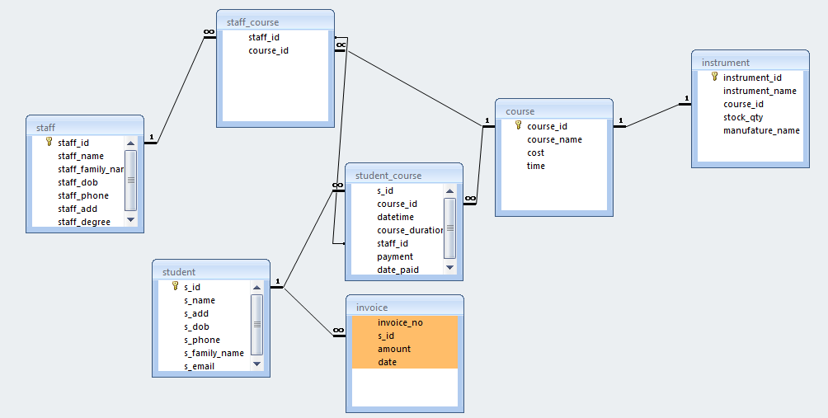

- Queries

- List details of students who are under 18 years of age.

SELECT student.s_dob as Date_Of_Birth, Year(Now())-Year([s_dob]) AS Age
FROM student
WHERE Year(Now())-Year([s_dob])<=18;

- Show details of lessons coming up in the next 7 days (if any).

SELECT a.course_id as Course_ID, b.course_name as Course_Name, b.time
FROM student_course AS a, course AS b
WHERE DateDiff('d',now(),a.datetime)<8 And b.course_id=a.course_id;

- Show a list of students and the total number of lessons they have had. Show the student ID, family name, given name, and the number of lessons.

SELECT a.s_id as Student_ID, b.s_name as Name, b.s_add as Addess, b.s_dob as Date_Of_Birth
FROM student_course AS a, student AS b
WHERE a.course_id =(select course_id from course where course_name='PIANO')
and a.s_id=b.s_id;

- Show details of any student who has had piano lesson.

SELECT a.s_id, a.s_name, a.s_family_name (select count(*) from student_course b where b.s_id =a.s_id)
FROM student AS a;

- Report.

1)
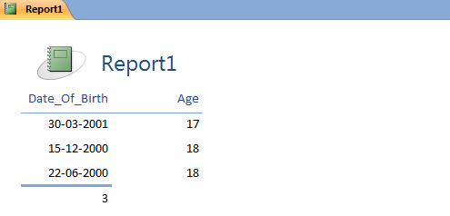
2)
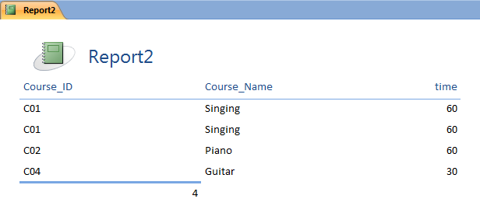
3)
